Description of the contract and required technical parameters

within the programme Investments in the Processing of Agricultural Products entitled

Modernisation of Yoghurt Production
PROJECT: Production Line PL7
Contents
1. Identification details of the Contracting Authority, contact details 1
2. Initial state of the company’s technical and production equipment 1
3. Investments related to the modernisation of the plant in previous years 1
4. Description of the planned investment 1
5. Justification of supplier selection 1
6. Packaging material for the new PL 7 1

Identification details of the Contracting Authority, contact details
Contracting Authority:
HOLLANDIA Karlovy Vary, s.r.o.
Company ID No.: 40522962
VAT ID No.: CZ40522962
registered office: Pražská 673, Miřetice u Klášterce nad Ohří, 431 51 Klášterec nad Ohří
data mailbox: yyhee3z
represented by: Ing. Petr Novák and Ing. Michal Škoda, company Managing Directors
Contracting Authority profile: https://nen.nipez.cz/profil/Hollandia

Contact person:
Ing. Roman Merkl, Ph.D.
mobile: +420 702 206 148
e-mail: r.merkl@hollandia.cz

Registered office of plant and correspondence address
Krásné Údolí 151
364 01 Toužim

Initial state of the company’s technical and production equipment
HOLLANDIA Karlovy Vary s.r.o. (hereinafter referred to as Hollandia) was established in 1991. Initially, production took place on a mobile line in an adapted production hall. However, as hygiene and quality requirements increased, these production conditions proved insufficient. Therefore, in 2002 we built a new production facility directly adjacent to the original plant. The new production premises are fully compliant with REGULATION (EC) No 853/2004 OF THE EUROPEAN PARLIAMENT AND OF THE COUNCIL and with the IFS international food safety and quality standards. Our company is subject to permanent veterinary supervision and has been regularly certified by an independent inspection body in accordance with the IFS standard since 2004.
Technical and production equipment of the plant
From a constructional and production perspective, the plant can be divided into two parts (see attached Figure No. 1):
- clean production area – milk treatment area, fermentation, filling, assembly
- technical facilities – fermentation containers, warehouses for finished products and materials, milk intake, technical facilities

The clean production area is constructed with light-coloured washable walls and seamless cast floors, enabling easy cleaning with a slope towards water drains and equipment for removing water. Wall-to-floor joints are rounded. Each room is equipped with hand-washing facilities with pre-mixed water, and water taps are not operated manually. Ventilation is provided by an internal air-conditioning system, ensuring positive pressure of sterile air in the production areas. Doors are plastic, easy to clean and resistant to corrosion.
The milk treatment department is equipped with a set of filters, a homogeniser and a pasteuriser with a capacity of 15,000 l/h.
The fermentation department currently contains 12 fermentation tanks.
The filling department is equipped with three automatic production lines and two semi-automatic lines:
- Filler PL 1 filling of products, diameter 95 mm
- Filler PL 2 filling of products, diameter 75 mm
- Filler PL 4 filling of products – interchangeable format, diameter 75 mm and diameter 95 mm
- Filler PL 5 filling of catering packs
- Filler PL 6 filling of products, diameter 75 mm

The production programme is based on two basic product types: farmhouse yoghurt – matured in the cup; creamy yoghurt – matured in the tank. The product portfolio is complemented by fruit variants, organic products and lactose-free products.

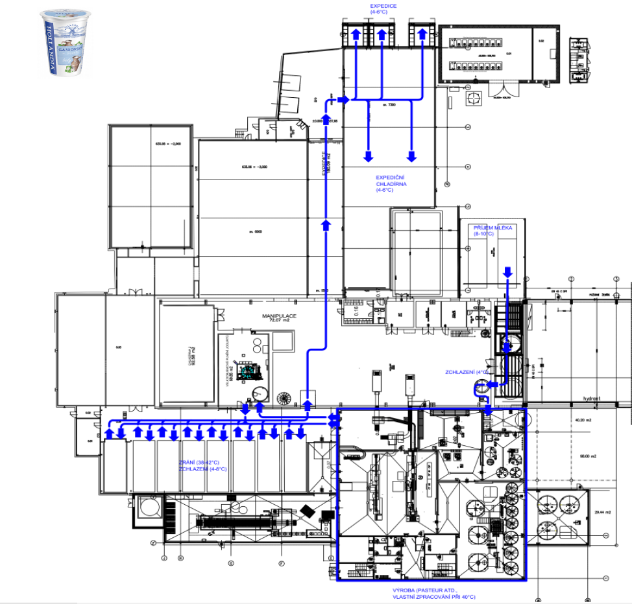
Figure 1 Diagram of the production plant showing the material flow in the production of farmhouse yoghurt.

The technical facilities are equipped partly with cast floors and partly with tiles. All surfaces are washable and easy to maintain. In the finished products warehouses and production cold stores, the temperature is controlled and electronically monitored.
Milk is collected using the company’s own dairy tankers; upon receipt, it is transferred into seven storage tanks with a total capacity of 155,000 l of milk.
Finished products warehouses and production warehouses are equipped with storage racking; one of the warehouses is equipped with mobile racks.
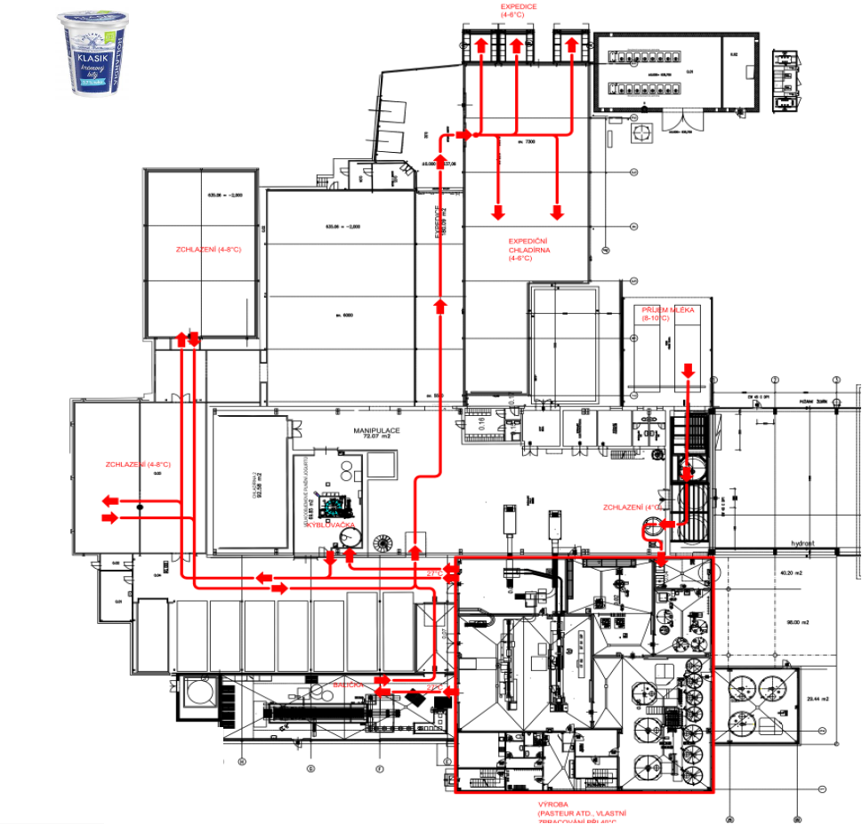
Figure 2 Diagram of the production plant showing the material flow in the production of creamy yoghurt.

A standard production day is repeated 365 days a year. From 7:00 pm, preparation of the technology begins (cleaning and disinfection of technological units) and preparation of yoghurt mixtures (pasteurisation, fermentation). At 5:30 am, filling on the production lines begins, according to the order structure and the production schemes above. Filling on the fillers normally continues until 5:00 pm, until all prepared mixture has been packed. The clean area around the production lines is then sanitised. Dispatching (emptying of fermentation containers and production cold stores) takes place at night. The implementation of the project described below must take place while the other parts of the technology are in full operation and must not restrict them in any way. All activities (relocation, connection to the technology, testing, training, etc.) must take place only after prior thorough planning and mutual approval, within time frames that will not restrict the existing production.

Products are dispatched via three dispatch ramps; products are distributed by external companies.
Figure 3 Diagram of the production proces.

Investments related to the modernisation of the plant in previous years

Hollandia has been carrying out significant investments in its production facilities on a continuous basis.
New technologies are focused on increasing automation, process standardisation, safety and quality and, last but not least, on improving energy efficiency and environmental sustainability. In recent years, investments have primarily concerned the modernisation of the cooling source, photovoltaic power plants, production lines and warehouse facilities.

Description of the planned investment
The objective of the planned investment is to replace the existing semi-automatic line (designated as PL 2 in Section 2) for filling yoghurt into cups with a more modern and more energy-efficient solution.
The current filling line is no longer sufficient to meet the continuously increasing requirements. Manufacturers of filling lines are responding flexibly to the current needs of the packaged food producers’ market. Ever-increasing food quality and safety requirements are leading to innovative solutions addressing the shortcomings of previous generations of lines. The yoghurt production technology itself runs in a closed system. The parameters of the production process are monitored both by computer systems and by experienced production operators. One of the most important steps is filling the premium-quality product into the final packaging.
Also, the limited flexibility of the existing filling line does not allow for an adequate response to current market requirements. The current filling line entails many limitations and shortcomings, both in terms of quality and from the perspective of product range diversity. The demanding work involved in mechanically adjusting the filling line when switching from creamy yoghurt to yoghurt matured in the package results in production downtime. The current line is also not equipped with a modern palletising end-of-line system, and very demanding monotonous work is still carried out manually.
The planned filling line should integrate the most state-of-the-art elements currently available in this field. For example, a cup blowing station will be required, where any foreign body is extracted from each cup immediately before filling, thus eliminating mechanical contamination of the product.
A station of highly efficient UV/C lamps treating the surface of cups and lids, together with more comprehensive enclosure by a laminar-flow cabin with overpressure of controlled sterile airflow, will significantly reduce the risk of the potential microbiological contamination of the yoghurt from packaging material.
Special filling heads, individually adjustable and controlled by servo motors, will ensure the containers are precisely filled with the required quantity. This will significantly reduce waste generation, both in terms of yoghurt itself and packaging material, where the difficulty involved in adjusting the current filling heads results in the production of dozens to hundreds of defective units with each recipe change.
Significant savings in energy and manual labour will be achieved by automating the entire production process. The required filling line must be capable of handling recipe changes, intermediate rinsing and sanitation fully automatically. The actual time required for a format change should be in the order of minutes, controlled via servo drives and software by the operator from the control panel.
The filling line must also include a carton sealing machine including feed conveyors. Advantages will include the full compatibility of the equipment, minimisation of losses and reduced need for pre-production of separators. At the same time, the overall efficiency of the entire system will increase, meaning the line can be operated by a maximum of three people. With a more efficient arrangement of buffer magazines, one worker will be able to operate the ‘clean’ section and ensure the supply of input materials; one operator will control the panel and manage the operation of the line. One worker will operate the ‘dirty’ section, including pallet and separator input. It will be possible to prepare cartons in the required time and quantities.

Technical specification:
Basic configuration
- Linear filling machine – minimum capacity 14,000 cups per hour for farmhouse yoghurt 500 g, for existing cups
- Cartoning machine – machine for sealing cartons of 12 pcs with separators from blanks, with output corresponding to the filler capacity, according to the specification in the annex
- Palletising machine (robotic palletising)
Filling machine
- Primarily intended for filling farmhouse yoghurt, creamy yoghurt, creamy yoghurt with fruit pieces (1*1*1 cm), using cups of 330 g, 400 g and 500 g in dry offset, K3 print, according to the cup specification at the end of the text
- At the required output – minimum 14,000 cups per hour for farmhouse yoghurt 500 g,
- For creamy yoghurt, a capacity of approximately 18,000 cups per hour for 500 g yoghurt is expected (high capacity due to the absence of foam), minimum 18,000 cups per hour.
- Flavouring component fillable at the bottom of the cup in the range of 30–120 ml
- Operating temperature range: Pre-filler 2–25 °C (fruit to the bottom of the cup), Main filling 30–45 °C (farmhouse yoghurt), at CIP 95 °C
- Individual recipes changed automatically from the control panel
- Potential for future expansion to include additional packaging variants (different cup heights, different cup shapes)
- At the required output, cup movement without unnecessary jerky motion and without the cups tilting. Cups must be handled gently to prevent damage to the final product.
- Complete employee injury protection – declaration of conformity in accordance with European legislation, light barriers, emergency stop and interlocking systems.
- Cup and lid magazines with capacity for at least 10 minutes of machine operation at maximum output.
- Cup and lid magazines refillable safely while the machine is running from floor level
- Gentle rejection of cups to eliminate cracking or chipping of cups
- Sensors to monitor low cup supply, missing or double cups
- Each cup must be perfectly clean before filling, without any mechanical impurities, e.g. vacuum extraction combined with blowing with sterile air, or inverted bottom-up and blown out with sterile air.
- Cups treated with pulsed UV-C radiation
- Pre-filling and main filling accuracy of 0.5 % by weight (for all lanes)
- Filled product quantity adjustable separately for each lane (multi-lane line)
- Drip-free filling when filling cups with individual product types, as well as drip-free filling of farmhouse yoghurt cups with milk product.
- Lid placement with automatic replacement of missing lids
- Lids treated with pulsed UV-C radiation
- Spot welding of lids to prevent position changes during line movement, without deformation of the cup or lid
- Sealing using a universal sealing head for aluminium and polypropylene lids, without deformation or other undesirable changes to the lid (burning of print, tearing of inner rings, difficult lid removal, etc.)
- Sealing head temperature adjustable separately for each head (multi-lane line)
- Seal integrity inspection station – for detection of minor seal leaks with efficiency higher than 99%
- Sorting parameters from the seal inspection station adjustable separately for each lane (multi-lane line)
- Marking station – two-line marking (date, batch); non-compliant unit without marking
- The entire area from cup placement to insertion into the conveyor after sealing must be under overpressure of sterile air from a laminar-flow cabin
- UV stations must be equipped with exhaust of emissions outside the production hall
- UV stations must not have high temperatures (below 70 °C to prevent deformation of PP lids)
- Maximum noise level at the location of most frequent operator presence below 73 dB; any vacuum pumps and fans must be located in an adjacent room on the northern or western side of the building (longer piping runs must be considered, as well as soundproofing elements, silent blocks, anti-vibration mats, etc.)
- Functional stations, conveyors and fencing must be made of thick-walled material with a minimum thickness of 3 mm; including wire infills, stainless steel DIN 1.4301, min. 3 mm (wire diameter). The entire facility must be washable with a water jet with the appropriate IP rating.
- Structural elements must be made of stainless steel.
- The structure must be made of closed stainless steel profiles so as to meet the requirements of hygiene standards and standards specific to the food production environment (easy to clean, without cavities retaining dripping water, etc.)
- Electrical cabinets of the facility must be made of stainless steel
- Conveyor bearings must be made of stainless steel
- Linear axes must be made of stainless steel
- The main drive chain must be automatically lubricated by a central lubrication system with adjustable operating mode
- The main conveyor must allow continuous washing during production with the option to set washing intervals
- The main conveyor must also allow continuous drying during production, the main belt must remain dry during production (e.g. due to the use of paper cups), and also without increasing the microbiological risk to the product due to spraying water and drying air
- Adjustable sanitation programmes for rinsing, CIP, acid solutions, hydroxide solutions, disinfection, water run-off. Sanitation must be carried out using automatically attachable adapters. Sanitation controlled by the operator exclusively from the operating panel.
Cartoning machine
- At the required output with sufficient performance reserve (approx. 25 cycles per minute), so that the output of subsequent equipment (filling line, palletisation) is not limited
- Precise gluing without dripping and 100% bonding of all required surfaces according to the drawings at the end of the text
- Compact facility with automatic glue replenishment with a glue tank of at least 200 l (adhesive used: Henkel Supra Cool 130)
- Blank magazine with a capacity enabling at least 20 min. of machine operation at maximum output
- Complete employee injury protection – declaration of conformity in accordance with European legislation, light barriers, emergency stop and interlocking systems.
- Protective doors transparent, polycarbonate – resistant to scratching and cleaning agents
- Maximum noise level in the installation area below 73 dB, any pneumatic components, servo motors, vacuum pumps must be adjusted or relocated to an adjacent area – the floor above the cartoning machine (longer routing must be considered, as well as soundproofing elements, silent blocks, anti-vibration mats, etc.)
- Functional stations, conveyors and fencing must be made of thick-walled material with a minimum thickness of 3 mm; stainless steel DIN 1.4301.
- The structure must be made of closed stainless steel profiles so as to meet the requirements of hygiene standards and standards specific to the food production environment (easy to clean, without cavities retaining dripping water, etc.)
- Electrical cabinets of the facility must be made of stainless steel
- Conveyor bearings must be made of stainless steel
- Linear axes must be made of stainless steel
- Drive protection rating at least IP 54.
Palletisation
- Automatic palletisation of finished products without the need for the operator to be continuously present. Robotic palletisation is already used on other lines, with which we have good experience.
- Primarily palletisation of existing products, 12 pcs into a separator, with cups 330, 400,
500 g in dry offset, K3 print, according to the specification in the annex
- Individual recipes changed automatically from the control panel
- Potential for future expansion to include additional packaging variants (different cup heights, different cup shapes)
- At the required output without unnecessary jerky movements and without the cups tilting. Cups must be handled gently to prevent degradation of the final product (mixing of flavouring component with milk in the case of farmhouse yoghurts, contamination of the lid with product)
- The entire area must be fenced to ensure safe movement of operators and safe operation of the line.
- Complete employee injury protection – declaration of conformity in accordance with European legislation, light barriers, emergency stop and interlocking systems.
- Maximum noise level in the area of most frequent operator presence below 73 dB, any vacuum pumps and fans must be located in adjacent areas (longer routing must be considered, as well as soundproofing elements, silent blocks, anti-vibration mats, etc.)
- Functional stations, conveyors and fencing must be made of thick-walled material with a minimum thickness of 3 mm; including wire infills, stainless steel DIN 1.4301, min. 3 mm (wire diameter). The entire facility must be washable with a water jet with the appropriate IP rating.
- All connectors, unless absolutely necessary, must be located at least 1 m above the floor.
- The design of protective elements, including robot fencing, must be made of stainless steel
- Conveyors must be made of closed stainless steel profiles so as to meet the requirements of hygiene standards and standards specific to the food production environment (easy to clean, without cavities retaining dripping water, etc.)
- Electrical cabinets of the facility must be made of stainless steel
- Conveyor bearings must be made of stainless steel
- Linear axes must be made of stainless steel
- Drive protection rating at least IP 54
- Correctly filled separators will be placed onto a pallet (standard pallet formats 1200 × 800, e.g. Euro pallet; EPAL – quality A, B) with a precisely defined adjustable stacking pattern to enable easy traceability of products.
- The palletising machine must be able to operate with different pallet heights – EUR / EPAL standardised pallets
- Safe and stable stacking up to the defined pallet height, most often 8–11 layers (range up to 1.8 m).
- Empty pallets will be placed onto the infeed conveyor individually by the operator after checking their quality
- Empty pallets will enter from the adjacent hall through a wall opening with dimensions 1600 × 550 at a height of 200 mm above the floor (location marked in the drawing), via a conveyor with a buffer capacity for at least 2 to 3 pallets. Transfer will be controlled by a demand signal to the adjacent technology.
- Light signalling indicating a pallet ready for removal – the final pallet will be removed from the end position, after being labelled with a pallet label by the operator, using a forklift truck.
Line control system and data integration
- Controlled from a local panel – PLC-based system, required compatibility with the higher-level Simatic S7 system used in the production plant.
Real-time status monitoring; alarms and diagnostic
Recipe management (different cup types, product types, number of pallet layers)
Possibility of industrial network connection (Ethernet/IP, Profinet, EtherCAT).
Storage of station status and fault history for diagnostics and product quality monitoring.

Installation, testing and documentation
Mechanical and electrical installation, in the shortest possible time during operation of other technologies. A detailed installation schedule shall be included in the bid
- Factory Acceptance Test (FAT) and Site Acceptance Test (SAT) – documented by a report signed by both parties without major defects.
- Operator and maintenance training.
- Complete documentation: Operating manuals, Maintenance plans, Wiring diagrams, Spare parts lists in the Czech language

Environmental requirements
- Operating temperature: 16–28 °C
- Humidity: 40 to 100 % (after the area has been washed)

The following figure shows a diagram of the installation area with indicated material inputs and outputs of the final product. The filler shown in the figure as a hatched rectangle (FILLER 7) should be located in a production hall with a ceiling height of 5900 mm. No legs supporting the main frame of the filler may be placed on the channel marked in Figure No. 4. It is essential to comply with the maximum filler width below 1900 mm, due to accessibility of the surrounding technology, where a forklift truck moves as indicated. This dimension is also the maximum due to the later-discussed possible access route for installation of the technology. Where this must pass through a gate with a width of 2000 mm. This parameter is fixed. The hatched area marked “AREA A” has a reduced ceiling height of 2800 mm. Products should be palletised in this area. The output of finished pallets with final products is indicated in the drawing and will be carried out using a forklift truck. This means that the entire conveyor system and end-of-line discharge positions must be sufficiently robust and stable. Pallets are normally stacked in 8 to 11 layers, but in principle this must be freely selectable from the operator panel while the machine is running. The hatched area marked “AREA B” also has a reduced ceiling height of 2800 mm. This area should be used to transport separators to a cup inserter, ideally built in. Separators will enter through the opening marked in the drawing, which may be appropriately enlarged by agreement. Separator conveyors must be positioned at a height above 2000 mm to allow passage and access to adjacent technology. The white area with dimensions 1600 * 3000 mm is reserved for placement of a pallet for potential non-standard products that must be removed from the standard flow in a non-destructive manner so as to allow subsequent analysis of the cause.
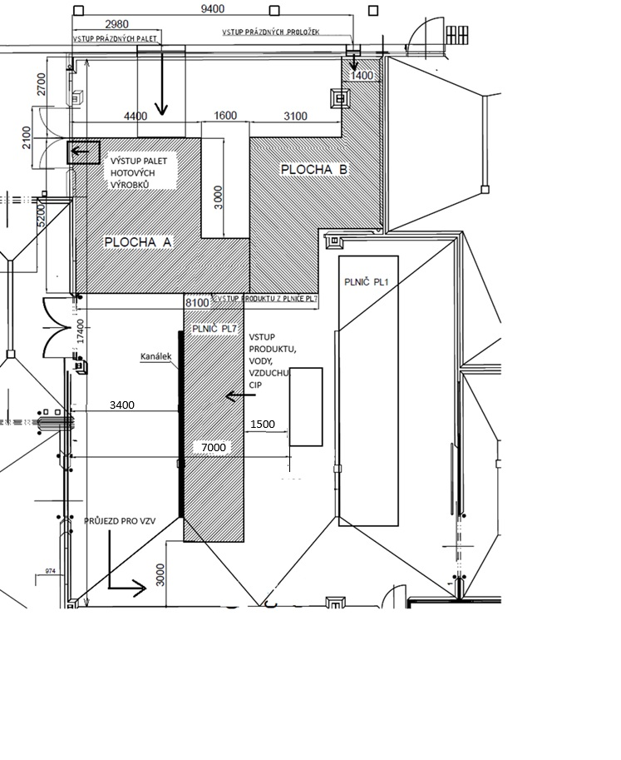
Figure 4 Layout diagram of the technology components of Filling Line 7 in the clean production hall.
A summary of the required parameters is clearly presented in the following table:
Table 1 Essential minimum parameters of the planned filling line.
Requirements for the new PL 7 filling line (95 mm)
Parameters | note | Compliance with requirement  (to be completed by supplier)
!Product (universal filling heads, without the need for replacement, easy to sanitise) | Farmhouse yoghurt  Creamy yoghurt  Creamy yoghurt with fruit pieces with maximum dimensions (1*1*1 cm)
!Filling temperatures | -Pre-filler 2–25 °C fruit to the bottom of the cup  -Main filling  8–30 °C creamy yoghurt  30–45 °C farmhouse yoghurt  -CIP 95 °C
!Cup | Round, diameter 95 mm, fill range 200–500 g  – recipe setting controlled by servo motors, each head adjustable individually
!Cup magazine  capacity for a minimum of 10–15 min | Serviceable from floor level, maximum conveyor edge height 1.2 m
!Lid | -Pre-cut aluminium, embossed and smooth  -Pre-cut PP  -with fast automatic changeover between recipes  -automatic addition of missing lids
!Stainless-steel design | Minimum AISI 304
Laminar-flow cabin above the entire open-cup area (from placement onto the conveyor to seal inspection) | Including pre-filters and HEPA filters
Cup cleaning station  (blowing with sterile air and extraction by vacuum) | Vacuum unit located outside the clean area
!Pre-filler | 30 – 120 ml, electronically controlled adjustment  -capacity approx. 50 l  -sight glass  -CIP-cleanable
!Main filling | 150 – 550 ml, electronically controlled adjustment  -capacity approx. 80 l  -Filling accuracy ±0.5%  -CIP-cleanable
CIP | -supply pump 14,000 l/h; 2 bar  -return pump 16,000 l/h  -CIP adapters fully automatic, without manual intervention, controlled from the panel; once per day
Lid magazine | -automatic replenishment without stopping the line, capacity for 30 min
!UV station | -adjustable radiation intensity  -effective smoothing  - exhaust fans with discharge outside the building; maximum noise level 73 dB
Sealing station | -temperature adjustable individually for each head  -protection against overheating of the atmosphere inside the cup during stoppage  -protection when the machine is being washed
Seal inspection | -non-compliant cup without date and batch marking, rejected outside the standard flow, error message on the panel, electronically adjustable for each lane separately
!Marking device – not supplied | -preparation for installation inside the machine  - VideoJet 1610 device to be installed  - direct purchase (not part of the tender)
!Belt cleaning and drying | -continuous cleaning and drying of the belt without negative impact on microbiological stability in the laminar cabin
!Output | -minimum 14,000 cups per minute for farmhouse yoghurt 500 g, for existing cups  -minimum 18,000 cups per minute for creamy yoghurt 500 g, for existing cups
!Energy | -average consumption during production 20–30 kW  -6 bar air for operation of pneumatic elements, max. 700 l/h
!Remote reporting | -via VPN
Integrated separator inserter | -placement into separators  -protection against potential collisions
Standard error messages | -missing cup, double cup  -glass breakage detection in the UV unit  -missing lid  -incorrectly sealed cup  -missing separator
Protective doors | -transparent, polycarbonate – resistant to scratching and cleaning agents
!Cartoning machine | -corresponding output, existing carton
!Palletisation | -automatic (robotic preferred);  Including pallet flow (conveyors)
Palletisation fencing and frame | Thick-walled material including wire infills, stainless steel DIN 1.4301, min. 3 mm thick
!Operating instructions  Complete spare parts catalogue  Maintenance manual  Electrical and pneumatic wiring diagrams | - in Czech
!Recipe change principle | -automatic (without operator intervention); material change only; within 10 min
!Number of operators | -maximum 3
Included in the price | -installation, commissioning, training, insurance
!Connection to existing dairy technology (Simatic S7) | Product for main filling, hot water, water, compressed air, N₂, product for pre-filler, steam, CIP, return CIP, higher-level control software – not included in the contract
Warranty | 24 months
!Support | Draft service agreement  - Online support 24/7 / 365 days a year  - On-site response within 6 hours of fault being reported

We plan to allocate a vacated area For the implementation of the technological complex for filling our products. This area will be located at the site of the decommissioned Filler PL2, which is under overpressure of sterile air and, from a construction perspective, complies with the requirements for a modern production hall. An easy-to-maintain floor sloped towards drainage channels, connected to washable walls with covings, and the area will be provided with controlled overpressure of sterile air ensured by a dedicated air-handling unit. Furthermore, the room will be equipped with a washbasin and a sanitation satellite for easy and effective sanitation.
For economic and spatial reasons, a compact layout of the filling equipment will be selected. This facility will have its own overpressure of sterile air, evenly distributed by a laminar-flow cabin. Incoming packaging material (cups and lids) will be treated using a modern and highly effective solution, pulsed UV-C radiation. Before filling, at one of the stations, the cup will be blown out with sterile air and its contents extracted in order to eliminate physical contamination. Batch marking of products will be carried out using a marking device Installed inside the machine. It will be standardised with the equipment of existing machines: VideoJet 1610DH. Preparation for marking of all lanes using a single device.
The filling equipment will be integrated into the existing technological complex in such a way that all required technological steps can take place without limitation and the unit becomes an autonomous, fully functional system. The connection and control of the technology will be provided by the existing supplier and will be implemented by direct purchase. Including connections for product, hot water, warm water, compressed air, rinse water, CIP return piping. These inputs must be marked in the drawing that will form part of the bid, with the required consumption of individual media, including parameters of the CIP return pump. CIP cleaning will be controlled by the filler; communication with the production software will be limited to the required medium and status. Cleaning will be carried out from the existing CIP station.
To enable filling of flavoured creamy yoghurts as well, the unit will be equipped with a separate mixing device. The device uniformly distributes large fruit pieces while at the same time minimising mechanical stress on the creamy yoghurt. The product will thus retain the consistency parameters previously achieved through gentle handling in earlier technological steps. This equipment will be procured by direct purchase and will ultimately function solely as a media input to the filler.
The investment will commence immediately after the contractor is selected in the tender procedure, following submission of the support application and signing of the contract. It is estimated that from the beginning of 2026, gradual implementation of individual parts of the project will take place in order to ensure smooth progress and minimal restriction of ongoing production. Completion of all planned investments and their commissioning is expected, in accordance with the programme conditions, by 30 November 2027.
Product range:
The new filling line must be capable of filling inoculated milk (including flavouring component to the bottom of the cup) into existing packaging at the required output during production of farmhouse yoghurts, at temperatures around 42 °C. It must also be capable of filling white yoghurt at temperatures around 27 °C, which in flavoured variants may contain fruit pieces up to a size of 1 cm³. The planned packaging material is described in a separate part of Chapter 6. Material samples will be provided during the site inspection of the filling location. Meeting the performance parameters is absolutely essential, as these will be required immediately after commissioning of the filling line and are critical for maintaining the standard material flow within the production plant.
Installation:
A critical point of installation will be transporting the production complex into the production hall. The only possible access route is via the loading docks of the MTZ warehouse, where the gate dimensions limit access to a maximum width of 2000 mm and a height of 2500 mm. Based on experience from previous installations, the maximum line length is approximately 8000 mm. The overall dimensions of the facility must fit within the above limits, or the facility must be divisible into smaller transport modules.
It is the responsibility of each bidder to measure, photograph and assess the space and any potential installation obstacles prior to submitting the bid during the site inspection of the filling location. The Contracting Authority bears no responsibility for any collisions when installing the line in comparison with the layout shown in the tender documentation.
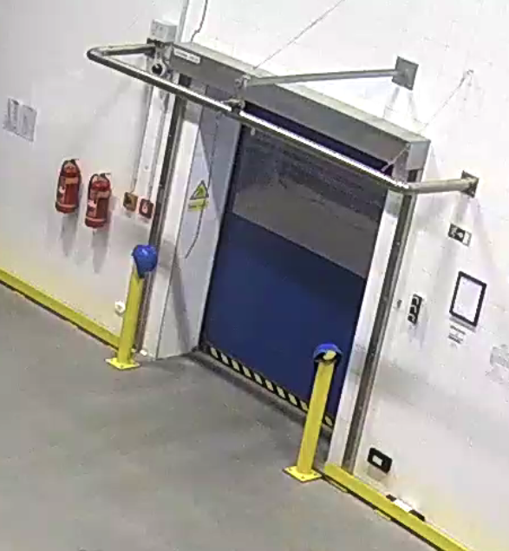

Figure 5 Narrowest point for transport of the facility.
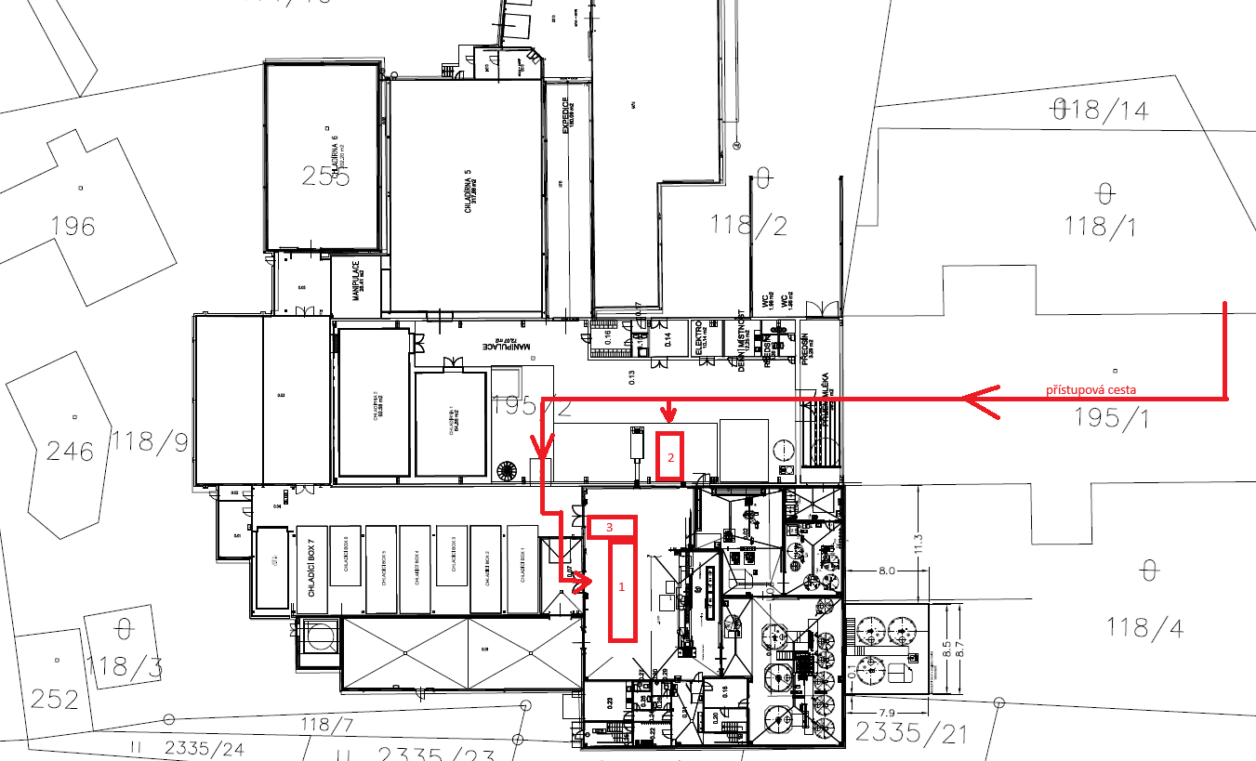

Figure 6 Diagram of the required layout of the technological complex including the indicated access route.
Figure No. 5 shows a schematic of the access route. The cartoning machine will be located in the so-called “old hall”, according to position No. 2 in the diagram above. The filler itself, the palletising end-of-line unit and conveyors will be located in the main production hall, according to positions No. 1 and 3. Precise measurements of the space will be made available to each bidder during the planned site inspection. It is the responsibility of each bidder to measure, photograph and assess the space and any potential installation obstacles prior to submitting the bid during the site inspection of the filling location. The Contracting Authority bears no responsibility for any collisions when installing the line in comparison with the layout shown in the tender documentation.

Justification of supplier selection
The selection of the equipment supplier will be carried out in accordance with the rules of the grant programme, i.e. so as to ensure that all project expenditures are reasonable and in line with the principles of economy, efficiency and effectiveness. The objective is to achieve the highest possible scope, quality and benefit of the fulfilled tasks in relation to the volume of funds expended.
The aim is to cooperate with a reputable manufacturer that shares similar corporate values. Key evaluation criteria will include quality, price, references, safety and functionality of the supplied filling line.
The parameters specified in Chapter 4 and also in Table No. 1 are critical, and compliance with these parameters is mandatory. Failure to meet the parameters will constitute failure to comply with the tender requirements and will result in exclusion from the tender procedure.
Compliance with the basic requirements will be necessary, whereby complete equipment with individual elements of the filling line will be required, enabling filling of the standard product range according to the drawings in Figures 7–12. Important selection criteria will also include the speed and efficiency of changeover between individual product types, so as to minimise the quantity of generated waste. At the same time, the equipment should be able to fill newly planned product types, which may differ in volume and marking method. The equipment must be fully compatible with the Simatic S7 control system used by us. Connection to the technology will be handled by the existing supplier by direct purchase – it is not included in and not the subject of this contract.
The supplier should be a reputable European manufacturer capable of providing 24-hour service 365 days a year; however, this is not a condition for conclusion of the contract for work. The supplier’s history, the number and success of already implemented projects, as well as fulfilment of the basic eligibility requirements by the tender participant, will be important.
Hollandia has been closely monitoring the market for these filling machines for more than a year, requesting comparable equipment with uniformly defined parameters so that the selection is based on objective indicators.
For the funds invested, we require technology assembled exactly to our needs in order to meet the continuously increasing quality requirements and also environmental friendliness.
Our goal is to increase the standardisation of steps following the yoghurt production process itself and to ensure gentler handling of finished products

Packaging material for the new PL 7
Cups – to be supplied by existing suppliers (PP – dry offset, K3)
- precise drawings and samples will be provided during the site inspection of the filling location
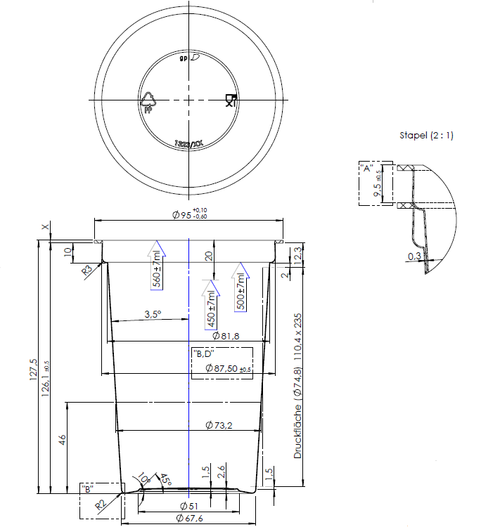
Figure 7 Cup 500 g
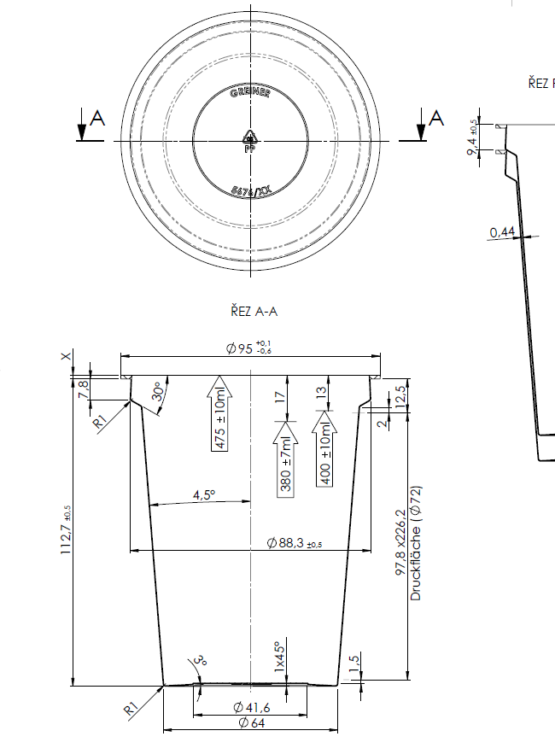
Figure 8 Cup 400 g

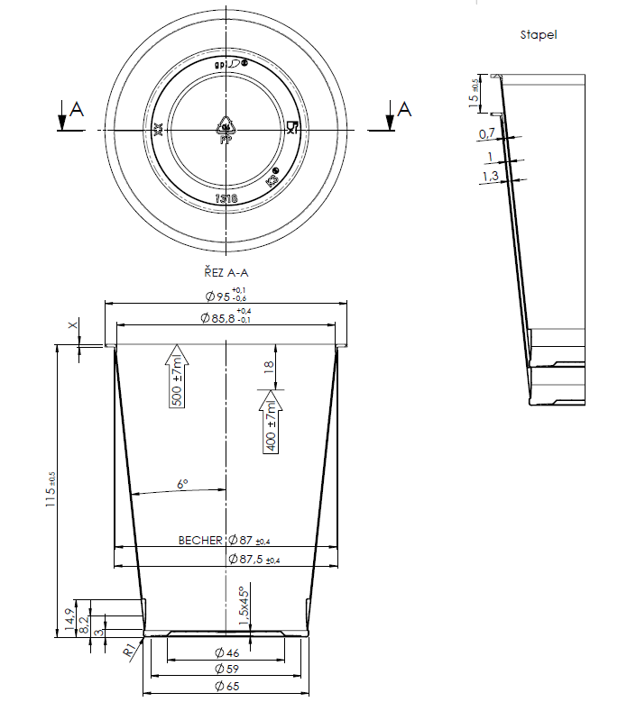
Figure 9 Cup K3 400 g
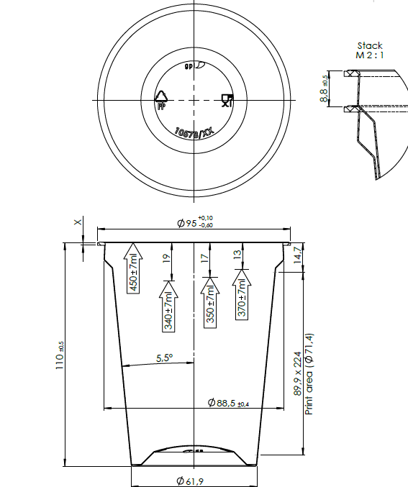
Figure 10 Cup 330 g

Lids – will be supplied by existing suppliers (ALU and PP)
- precise drawings and samples will be provided during the site inspection of the filling location
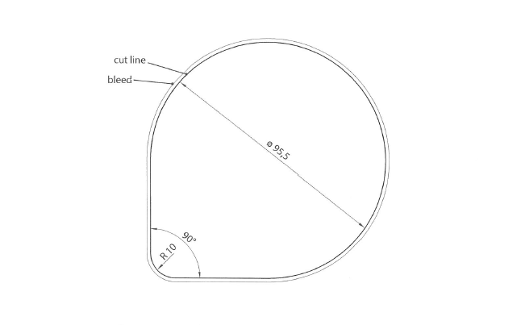
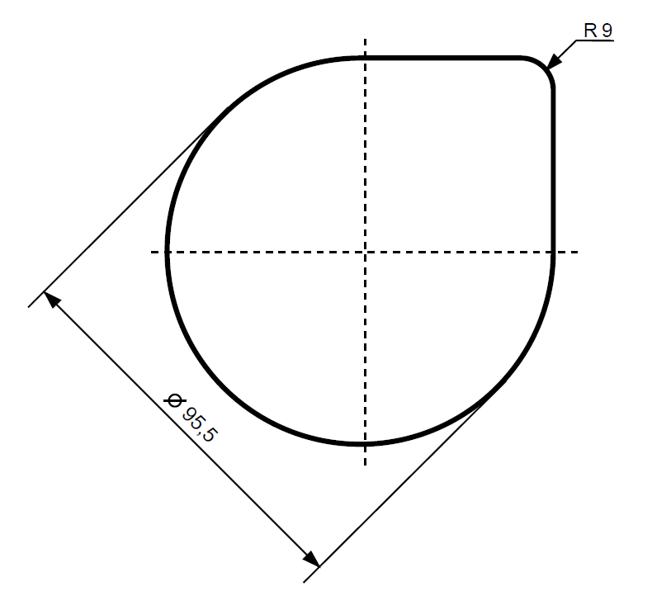

Figure 11 Lid Alu or PP 95 mm
Separators – to be supplied by existing suppliers (for 12 cups according to the specification above)
- precise drawings and samples will be provided during the site inspection of the filling location

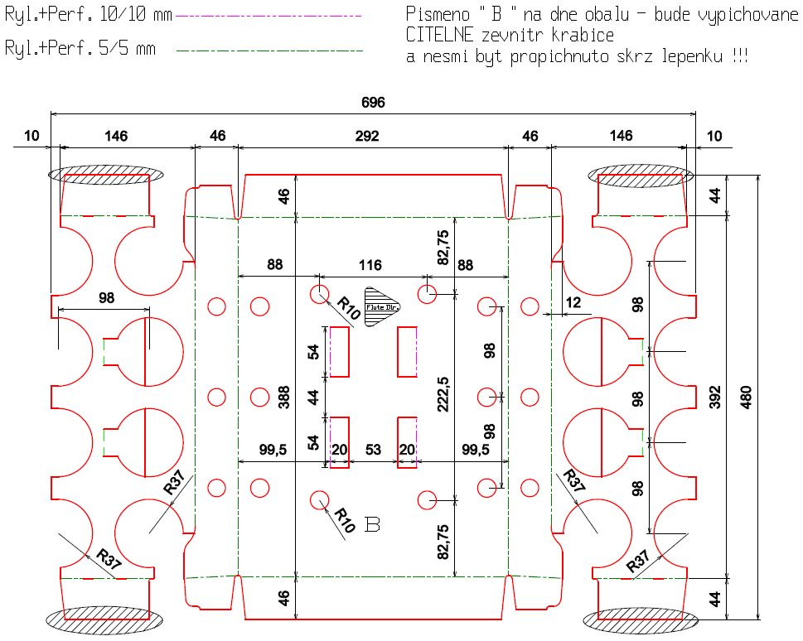

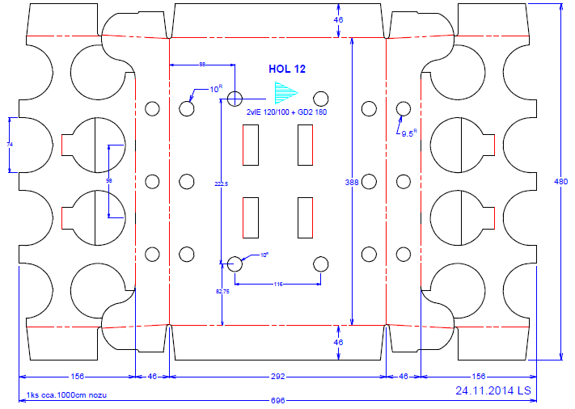

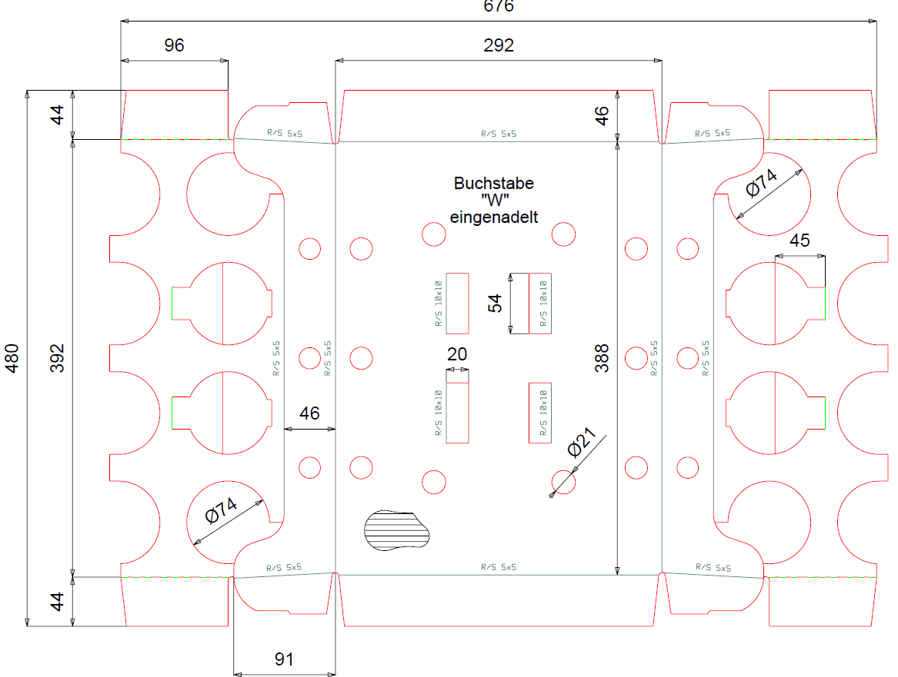

Figure 12 Separators 12 pcs

