Frequently Asked Questions
WHAT IS NEW IN THE EU CATCH CERTIFICATION SCHEME AFTER THE AMENDMENT OF THE EU IUU REGULATION AND OF THE EU IUU IMPLEMENTING REGULATION
(December 2025)
GENERAL QUESTIONS ON CATCH
- What is CATCH?
CATCH is an EU-wide real-time IT system for the management of all procedures linked to the EU catch certification scheme. It allows for the submission of all catch certificates and related documents accompanying the fishery products to be imported into the EU in accordance with the EU IUU Regulation (Council Regulation (EC) No 1005/2008) as amended by Regulation (EU) 2023/2842 of the European Parliament and of the Council of 22 November 2023[1].
The main objective of CATCH is to streamline the catch certification process and all linked procedures and to offer a fully digitised and paperless workflow. It facilitates the exchange of data, information and documents between all involved trading parties and control authorities and therefore simplifies and speeds up the administrative procedures.
CATCH is intended to improve the effectiveness of the EU IUU Regulation’s catch certification scheme by ensuring a centralised digital management environment with the objective to identify and prohibit importation into the EU of fishery products obtained from IUU fishing.
CATCH offers the possibility to create, validate and submit catch certificates and/or related documents by non-EU countries’ operators and authorities.
- Who are the users of CATCH?
According to the amended IUU Regulation, EU importers and the competent authorities of the EU Member States are subject to the mandatory use of CATCH in the context of the catch certification scheme.
For the importation of consignments of fishery products into the EU, importers shall submit to the competent authorities in the Member States the required documentation and the information contained therein through CATCH, and Member States’ authorities shall process such submission through CATCH.
However, CATCH also allows non-EU countries’ operators and authorities to create, validate, and transfer catch certificates and related documents directly in CATCH. As such, the production flow of relevant data and documents can become digital from the source of the product (exporting flag State) to the final destination (importing Member State).
- Is the use of CATCH compulsory?
The use of CATCH is compulsory for EU importers for the submission of the catch certificates and related documents and the information contained therein, referred to in Chapter III of Council Regulation (EC) No 1005/2008, to the EU Member States’ authorities as of 10 January 2026.
Non-EU countries’ exporters and authorities are able to use the system on voluntary basis. It is not compulsory for them but strongly recommended.
- When will CATCH become compulsory?
As of 10 January 2026, the importers of fishery products in the EU have to submit the catch certificates and related documents and the information contained therein to the authorities in the Member States through CATCH.
- When can I start using CATCH?
The system is already up and running, which means that catch certificates, processing statements (Annex IV),importer declarations and other related documents can be created via CATCH. However, this is only mandatory for EU competent authorities and EU operators.

Access to CATCH training environment for non-EU countries’ operators and authorities has been enabled in October 2025. Access to CATCH to generate, validate, endorse or sign catch certificates and other related documents will be granted to non-EU countries that at any time express interest to directly use CATCH.
5.a. What actions must be taken by non-EU countries to gain access to CATCH?
In order to be granted access to CATCH, a non-EU country needs to confirm the Commission that, in accordance with Article 6a(7) of the Implementing Regulation (EC) 1010/2009, that (a) it has the legal and operational capacity to provide, without undue delay, the assistance necessary to allow the good functioning of CATCH, and (b) it has designated a contact point for that purpose.
For general technical actions/requirements to access CATCH, see Q6.
- How can I gain access to CATCH?
CATCH is a web-based digital environment which is part of TRACES NT. New users can apply for access directly through the system.
The first step is to create your EU login account[2] if you do not already have one. This is a mandatory security layer. Once you have created your EU login, you must request a role to have access to TRACES NT, as either an Operator or an Authority.
The European Commission provides access only to the first user of the notified competent authorities in EU Member States and in non-EU countries. Subsequently, the process follows a delegated access management model (competent authorities granting access to other users in those authorities and to operators and their first users).
This means that the first operator user (importer) will have to be linked to an operator company and be validated by its responsible authority. This operator user should select the competent authority with CATCH domain in its country. The competent authority should validate the operator’s request in TRACES NT.
Validation of users must be done individually (user by user). The users EU login accounts should be created by using their individual email address (and not a generic email address/functional mailbox). There is no limitation to the number of users per authority or per company.
- For more information on the EU login on the TRACES documentation website, please find information here. What languages will CATCH be available in?
CATCH will be available in all official EU languages.
- Will CATCH ensure a paperless workflow in the EU catch certification scheme?
To achieve a complete paperless workflow, non-EU countries' operators and authorities will have to use CATCH directly.
The obligation to submit the relevant information and documents via CATCH is for the EU importer. The direct use of CATCH for the creation, validation and endorsement of documents by non-EU countries’ operators and authorities, although highly recommended, is voluntary.
Non-EU countries’ operators and authorities can decide to continue using paper-based certificates or to directly use CATCH to create and validate catch certificates and related documents.
If an EU importer continues to receive the documents in paper format, this importer will be required to enter the data from such documents manually in CATCH (and upload the scanned paper documents).
The European Commission is offering to interested non-EU countries that have IT systems capable of creating catch certificates for exports to the EU, the possibility of establishing interoperability through webservices between these IT systems and CATCH, on the condition that the aforementioned systems comply with the data requirements and system’s security as laid down in CATCH.
The European Commission is promoting the direct use of CATCH by non-EU countries, highlighting the benefits for trade facilitation, like speeding up the administrative procedures at the border, increasing the reliability of data, the fact that the use of the tool is free of cost and that the system is available 24 hours a day in all EU official languages, etc.
The European Commission also encourages EU importers to promote the direct use of CATCH with their non-EU countries’ suppliers.
Currently, more than 113.000 users from about 90 countries worldwide are using TRACES directly, meaning that they create certificates and documents online for trade of food, animals, organic products, and other commodities. Some of these non-EU countries have already shown interest in the direct use CATCH.
- What are the benefits of the use of CATCH for EU Member States’ authorities?
CATCH enhances cooperation and coordination between the competent authorities of the EU Member States and between economic operators and their competent authorities. The main objectives of CATCH are:
- to allow for the detection of fraudulent catch certificates;
- to prevent overuse of catch certificates through quantity management when catch certificates are used several times in relation to different consignments destined to the EU market;
- to support risk management applied to official controls;
- to harmonise the documentary workflows.
- What are the benefits of the use of CATCH for the operators?
CATCH harmonises the procedures foreseen under the EU catch certification scheme. In addition, it will speed up the administrative procedures, it will facilitate the submission of required data by providing a “copy as new” function that will allow the re-use of information previously introduced in the system and will provide a multilingual environment.
Once non-EU countries choose to use CATCH directly, it will also make the entire process easier as all the workflows will be electronic.
- What training is needed to use CATCH? Will the European Commission provide it?
The European Commission has provided training to the EU Member States’ authorities. In addition, there is an extensive set of online user material on the CATCH documentation web page (as part of the TRACES NT documentation website). EU operators and authorities can consult user manual (available here) and pre-recorded training videos (available here). These training materials will be updated as necessary.
As regards non-EU countries, regional and bilateral information seminars have been organised by the European Commission, and a specific page has been created on the TRACES NT documentation website for non-EU operators and non-EU authorities [3].
- Is a manual for using CATCH available?
A users’ manual is available on the TRACES NT documentation website, under the CATCH module[4]. This manual is publicly available (even without login into TRACES NT). As CATCH developments will continue, the manual might not always reflect the latest changes made to the IT environment.
- What if CATCH does not work?
Contingency measures are laid down in the implementing provisions to address situations when the system is not available to users.
Note that planned maintenance and possible unavailability of TRACES NT is announced well in advance through alert messages in the TRACES NT platform to all users. When you login, you can see these alerts.
- What is the European Commission doing to encourage non-EU countries’ operators and authorities to use CATCH directly?
The European Commission is promoting the use of CATCH by non-EU country operators and authorities through seminars, trainings and exploring interoperability solutions for those non-EU countries that already have IT systems for validating catch certificates.
CATCH is part of TRACES NT, an online platform, developed by the European Commission in the early 2000’s, for sanitary and phytosanitary certification required for the importation of animals, animal products, food and feed of non-animal origin and plants into the EU. TRACES NT is already used by 90 countries worldwide and some of them have already showed interest in using CATCH for the catch certificates and related documents.
The use of the system by non-EU countries will provide more certainty to the data and for them it will facilitate trade. The continued use of paper catch certificates will be a burden for EU importers, hence products accompanied by paper catch certificates would inevitably be subject to longer import procedures.
- Is it possible to add attachments to the catch certificate in CATCH?
Yes, this is possible. In case the catch certificate has been transmitted by the exporter to the importer in paper format, the original catch certificate must be scanned and uploaded in CATCH as accompanying document. It is also possible to scan and upload other documents related to the catch certificate submission in CATCH.
- Are non-EU countries able to connect their IT systems generating catch certificates to CATCH?
The European Commission is open to engage in discussions with interested non-EU countries about interoperability between CATCH and their national IT systems, developed and used for the generation and validation of catch certificates.
This interconnection must be ensured through web services. The pre-requisite for establishing interoperability with CATCH is the ability of the national systems to provide all data and information required in the catch certificate and related documents under Chapter III of Regulation (EC) No 1005/2008 as amended by Regulation (EU) 2023/2842 of 22 November 2023. See also Q8.
The European Commission is currently engaged in discussions with several non-EU countries to establish interoperability.
- Who has access to the data validated by non-EU countries in CATCH?
Information from catch certificates and any other documents foreseen under the catch certification scheme must be submitted, through CATCH, to EU Member States’ authorities who check and verify this information and take decisions on authorisation or refusal of importations.
The use of personal data in this context is limited to the implementation of the objectives laid down in Regulation (EC) No 1005/2008. Regulation (EU) 2016/679 of the European Parliament and of the Council on the protection of natural persons with regard to the processing of personal data and on the free movement of such data, and Regulation (EU) 2018/1725 of the European Parliament and of the Council on the protection of natural persons with regard to the processing of personal data by the Union institutions, bodies, offices and agencies and on the free movement of such data, apply to the information processed through CATCH.
- Will non-EU countries’ authorities be able to extract data they have validated in CATCH?
Yes, non-EU countries’ authorities will be able to access and extract data that they have validated or endorsed through CATCH. However, they will not have access to data validated or endorsed by other countries’ authorities.
They will be able to extract this data via the QlikSense tool in CATCH, a functionality that can provide statistical data based on information submitted through the system.
- If a non-EU country already uses TRACES NT to validate other certificates, does it need to request a new access to use CATCH?
The authorities’ users that have already an EU Login in TRACES NT, can also use it for CATCH. However, they need to request an extra role to access CATCH.
The authorities from non-EU countries that will be provided a role in CATCH by the European Commission are those notified to the European Commission under Article 20 of Council Regulation (EC) No 1005/2008 (flag State notification) and other authorities in charge of implementing other provisions laid down in the EU catch certification scheme (for example the endorsement of documents referred to in Article 14(1) and 14(2)).
- Is there an open-source version of CATCH that could be used by non-EU countries?
No, there is no open-source version of CATCH available. CATCH is a web-based system that can be used by non-EU countries after creating an EU login account and requesting a role to have access to TRACES NT, as "Operator" or "Authority”. The purpose of giving access to CATCH to non-EU operators and authorities is to give them the possibility to create and validate catch certificates and related documents, required for exporting fishery products to the EU, directly in the IT system instead of having to issue these documents on paper.
CATCH is not a database that can be used by non-EU countries for other purposes than the one described. It should be noted that the authorities of non-EU countries that are registered in CATCH are only able to access data that they have validated through CATCH, and not information from other countries.
- Is CATCH based on the UN/CEFACT standard?
Yes, CATCH is based on the UN/CEFACT standard.
- Has the European Commission adopted implementing regulations to lay down the rules for the functioning of CATCH?
Yes, the rules for the functioning of CATCH were adopted on 25 July 2025 and are available here. See Q75 to 78 for further information.
- What is the procedure to be followed for using CATCH to validate catch certificates if a non-EU flag State has not previously used TRACES NT?
The first step is to create your EU login account, if you do not already have one. This is a mandatory security layer. Once you have created your EU login, you must request a role to have access to TRACES NT, as either “Operator” or “Authority”.
The European Commission provides access only to the first user in each of the notified central competent authorities of non-EU countries (authorities in non-EU countries that are notified under Article 20 of the Council Regulation (EC) No 1005/2008 to validate catch certificates). Subsequently the process follows a delegated access management model (central competent authorities granting access to other users in the authorities and to operators and their first users).
More information can be found on the TRACES documentation website, here.
- Is a non-EU country that has not notified its authorities as flag State under Article 20(1) of Council Regulation (EC) 1005/2008 able to validate catch certificates in CATCH?
No, according to Article 20 of Council Regulation (EC) 1005/2008, catch certificates validated by a flag State can be accepted by Member States only when that flag State has notified to the European Commission the information required by paragraphs 1 and 2 of the said Article and Annex III of the mentioned Regulation. If the authorities of a country are not notified to the European Commission, the creation of a catch certificate for vessels flying the flag of that country is not possible in CATCH.
- Is a non-EU country that has not notified its authorities as flag State under Article 20(1) of Council Regulation (EC) 1005/2008 able to use CATCH?
Yes, non-EU countries other than the flag States notified under Article 20(1) of Council Regulation (EC) 1005/2008 can create, sign, declare or endorse other documents / information in CATCH, e.g. processing statements (Annex IV), non-manipulation documents, landing/transhipment events.
- Can flag States replace a catch certificate that was created and already validated by them directly in CATCH?
Yes, the flag State’s authority must first cancel the already validated catch certificate and ask the exporter to create a catch certificate in CATCH.
To quickly create a new catch certificate, there are two possibilities. The exporter can use the functionality “copy as new (reissued)” based on the cancelled one. This functionality will automatically create a link between the new and the cancelled catch certificate. The exporter can use the functionality “copy as new” based on the cancelled one. However, the latter option requires a manual creation of a link between two certificates by adding the certificate reference of the cancelled one in the section “supporting documents”. After all necessary steps are completed, the newly created catch certificate will be submitted to the flag State authority for validation and a new document number will be assigned.
- What is the relationship between CATCH and the RFMO catch documentation schemes, recognised as equivalent to the EU catch certification scheme in accordance with Article 13 of Regulation (EC) No 1005/2008?
For the Catch Documentation Schemes recognised as equivalent to the EU catch certification scheme, operators and authorities will continue using and implementing the said schemes and their IT platforms. It is not possible to create or introduce these catch certificates and any related document in CATCH.
These documents are not included in the list of documents that the operators must submit through CATCH to Member States’ competent authorities in accordance with Article 6a, point 1 of the amended Implementing Regulation (EC) 1010/2009, as amended by Implementing Regulation (EU) 2025/1522.

In case the exporter or importer selects in CATCH one of the species covered by such RFMOs Catch Documentation Schemes, they will be informed that they must use the corresponding RFMO Catch Documentation Scheme IT environment. The link to the relevant RFMO IT environment will be provided.

- What is the relationship between CATCH and the RFMO statistical documents?
Species covered by statistical documents according to RFMOs rules are also subject to the EU catch certification scheme requirements. A validated catch certificate should therefore be submitted through CATCH in addition to the statistical document requirements.
The submission of the statistical document in CATCH is not mandatory, however the importer has the possibility to upload scanned copies of these documents as complementary information to the submission through CATCH.
QUESTIONS on CATCH RELEVANT TO EU IMPORTERS
- I am an EU importer: do I need to register to use CATCH? To whom should I direct my request for registration?
Yes, you must log in into TRACES NT first. To do this, you need an EU login account, which is the first step.
Once you have registered in EU login, you can log into TRACES NT and request a role that will allow you access to the application.
If you represent a company, you are an operator user and therefore, on the login screen you can select a role in TRACES NT as “Operator”.
If your company does not exist yet in the system, you can create it by clicking “create a new operator”. After that, you have to select the responsible authority by searching for the competent authority with CATCH domain in your country[5]. This authority must first validate your company in the system, and then validate you, as a first user linked to that company.
29.a. I am responsible for the consignment/load: do I need to register in CATCH? If so, how do I register? To whom should I direct my request for registration?
Both the importer company and the importer’s representative company need to be validated in CATCH by a competent authority as they are both included in the importer declaration. Please note that the importer’s representatives have their own role in CATCH (under section “Responsible for load” and not “Fishing”), and they need to be validated in TRACES NT by the Member State’s BCP authority.
To be noted that if the entire procedure in CATCH is always carried out solely by the importer’s representative, then it is not necessary to have a user linked to the “importer” operator company.
29.b. I am responsible for the consignment/load: what are the actions that I can perform in CATCH?
The responsible for the load can enter into CATCH the information from a paper-based catch certificate, processing statements (Annex IV) and non-manipulation documents. This responsible for the load can then submit the importer declaration to the relevant Member State competent authority. However, the responsible for the load cannot create a catch certificate for exportation or re-exportation, nor a processing statement, as its role is only linked to the importation workflow.
In order for responsible for the load to be enabled to create documents in CATCH other than those related to importation, the responsible for the load company needs to obtain a role under the Section “Fishing”.
- I am an EU importer: how to use CATCH if I receive a paper catch certificate from the exporter?
Once you are registered in TRACES NT and your competent authority has validated your role as operator, linked to a company with the activity “fishing importer” (or representative of the importer), you can access CATCH and fill all required information related to the catch certificate and other relevant documents by copying this information from the paper version into CATCH.
You have to introduce all the information from the paper catch certificate into CATCH, following the different steps. All information fields marked with a red asterisk are mandatory.
In case you receive the catch certificate and other documents in their paper format, you still have to submit the originals to the competent authority in your Member State. The original paper catch certificate must be scanned and uploaded as accompanying document, in section “Supporting documents”.
- For more details, see the training material available on the TRACES NT documentation website, under the CATCH module. Do EU importers still have to submit the original catch certificate in case that the non-EU country is not using CATCH?
Yes, if the importer receives the catch certificate on paper, the importer has to submit it, together with all relevant documents foreseen under the catch certification scheme, to the Member State competent authority. In addition, the importer has to fill in the data required in CATCH and to upload a scanned copy of the original catch certificate and of the other relevant documents in CATCH.
- I am an EU importer: what if I receive a paper catch certificate and some of the mandatory information is not provided?
You cannot create and submit the catch certificate in CATCH if all the mandatory information is not provided. You have to contact your exporter to obtain a complete catch certificate. The exporter has to contact the relevant flag State authority which needs to cancel the incomplete catch certificate and replace it with a complete one.
- I am an EU importer: how to use CATCH if I receive from the exporter a catch certificate created and validated directly in CATCH?
If the non-EU country created and validated the catch certificate or other documents directly in CATCH, you receive them from the exporter directly in CATCH. The exporter has to fill in the section “update next operator” in the transport details tab to indicate you as the EU importer to whom the catch certificate and other documents will be submitted in CATCH. Once submitted, you will receive a notification, and you can then proceed by launching the importer declaration.
- I am an EU importer: once the catch certificate is available in CATCH, what should I do to launch the importer declaration in the system?
You must launch the importer declaration by clicking on the button displayed at the bottom right of the valid catch certificate page, “new follow up” and then “launch importer declaration”.
The commodities related to the importer declaration must be selected using the EU Combined Nomenclature (CN) code. You must indicate the net fishery product weight in kg (this refers only to the fish component of the product to be imported, without other ingredients such as water, oil, vegetables....) as well as the net weight in kg of the products to be imported (including the fish component and other ingredients).
- CATCH allows the use of several catch certificates and related documents in the same importer declaration. I am an EU importer: what should I do when I receive a catch certificate directly created and validated in CATCH and a paper-based processing statement (Annex IV)?
In this case, you must introduce the information from the paper processing statement (Annex IV) into CATCH. To do that, you go to the homepage of CATCH and select the button displayed on the top-right of the page “Create new processing statement” followed by “From catch certificate”. After entering the requested details, the processing statement page is displayed, with the valid catch certificate linked to it.
For the identification of the commodities in the processing statement (Annex IV), the EU Combined Nomenclature (CN) codes must be used.
You have to introduce the information from the paper processing statement (Annex IV) that was not automatically transferred from the related catch certificate(s). All information fields marked with a red asterisk are mandatory.
A scanned copy of the processing statement (Annex IV) must be uploaded as accompanying document. The health certificate, if available, can also be uploaded.
Once all the information of the processing statement (Annex IV) has been introduced in CATCH, you click the button “finish document”. The document should appear in CATCH as “valid”.
After this, you launch the importer declaration.
- In case that the processing statement (Annex IV) refers to several catch certificates, it should be first ensured that all the catch certificates are already in CATCH before creating such processing statement. If they are all there, the system allows to link the processing statement with several catch certificates. I am an EU importer: what if I receive a paper processing statement (Annex IV) and some of the mandatory information is not provided?
You cannot submit the processing statement (Annex IV) in CATCH if all the mandatory information is not provided. You must contact your exporter to obtain a complete processing statement (Annex IV). The exporter has to contact the relevant endorsing authority which needs to cancel the incomplete processing statement (Annex IV) and replace it with a complete one.
- I am an EU importer: l lose a lot of time copying all the data from the paper certificates and related documents into CATCH. There is a lot of information to provide.
For the first documents introduced in CATCH, the information has indeed to be entered manually. However, once CATCH is in use, the workload should be quickly reduced as CATCH includes the option “copy as new” which allows you to quickly create a new catch certificate, or processing statement (Annex IV), based on a previous one. This action will speed up the submission process. Much of the data can be re-used, such as fishing vessels, exporter details and information on flag State authorities.
CATCH also includes the selection of favourites (operators, fishing vessels, catch areas and masters) which allows you to quickly fill in part of the certificate. This also speeds up the submission process.
Nevertheless, the best option would be to invite exporters to submit the catch certificates to their authorities directly in CATCH. This will ensure a paperless document workflow.
The European Commission also promotes the direct use of CATCH among non-EU countries and offers interoperability between IT systems. See also Q8 and Q16. 37.a. I am an EU importer: do I have to copy into CATCH the data from the paper processing statement (Annex IV) which are the same data as provided in the catch certificate related to this processing statement?
No, the processing statement in CATCH is always created on the basis of the related catch certificate(s) that have been introduced in CATCH before the creation of the processing statement. In this way, all relevant data from the catch certificate(s) are automatically transferred into the processing statement (i.e. the catch certificate number, vessel name and flag, validation date, catch description and the weight declared in box 3 of the catch certificate).
- Please note that, thanks to the functionality “copy as new”, a previously entered catch certificate with the same/similar data as provided in a new catch certificate can be reused to create that new catch certificate. I am an EU importer: how do I receive authorisation for import from the competent authorities in my Member State in relation to a consignment and related documents submitted through CATCH?
Once the importer declaration has been completed, you must submit it for import control through CATCH. The catch certificate and all other documents, together with the importer declaration, are then received by the relevant Member State’s competent authority. The status “Import control authority notified” will appear.
The import control authority must authorise or refuse the importation. You will receive, through CATCH, a notification when this is done.
- Is it possible to correct a catch certificate/processing statement (Annex IV) in CATCH and who can make the corrections? If not, how are typographical and keyboard errors managed in the system?
Two solutions have been developed in CATCH to correct typo errors made by importers when copying the paper catch certificate into CATCH. Before the submission to the import control authority, the importer can use the REPLACE functionality (which will be renamed “AMEND” in the future). After the submission, the importer can make the corrections only after the import control authority has sent the catch certificate to the importer for amendment. In this case, the importer will use the same AMEND functionality.
The REPLACE functionality allows the importer to correct data copied from the catch certificate and pre-validated in CATCH, whilst cancelling the original one. The system creates a link between both certificates. To do that, the importer will need to open the catch certificate with the errors (and not linked to any importer declaration), click on the “More” button at the bottom of the page, and then on “Replace”. Once corrected, the importer clicks on “Finish document” and the status is “valid”.
The AMEND functionality allows the importer to amend a catch certificate, already linked with other documents and submitted with an importer declaration to the Member State authority. To do that, the Member State authority (import control authority) will need to open the importer declaration, click on the “More” button on the bottom of the page, and then on “Send certificates for amendment”. The authority will select the certificate in question and mark the box(es) to be amended. The importer will then receive a notification stating that the catch certificate (CATCH.CC) is ready to be amended. When the importer opens it, the status is “To be amended” and only the box(es) marked by the Member State authority is opened for edition, together with a comment from the authority. Once amended, the importer clicks on “Amend document” and the status of the certificate is “Amended”. The Member State authority will then receive a notification and can proceed with the decision on importation.
- How is the catch certificate transferred in CATCH from the exporter to the EU importer or to the processing plant?

Once the exporter has a “VALID” catch certificate (validated by the competent authorities of the flag State directly in CATCH) and the “Transport details” tab is filled in, the exporter can then submit the catch certificate to the relevant operator by completing the section “next operator” in the “Transport details” tab. The exporter should click on the button “Update next operators” to transmit the document to the receiving relevant operator. The next operator then receives a notification. One or more operators can be added in that section.
- Does CATCH send automatic notifications to operators (importers, customs agents, etc.) when a catch certificate has been validated?
After the non-EU flag State competent authority has validated one or more catch certificates related to a consignment, the exporter having submitted such certificate for validation receives a notification in CATCH. The exporter is then able to transfer such certificate(s) to the importer in the EU, thus providing them access to the certificate in CATCH, through the “Next operator” section (see Q40). The importer receives a notification in CATCH and once the catch certificate has been submitted for import control, the Member State competent authority will also receive a notification.
For activation of notifications and setting of preferences, please refer to the user manual.
- Will CATCH be covered by the EU Single Window Environment for Customs? Will customs authorities be notified of the IUU import authorisation or refusal provided by IUU competent authorities through CATCH?
Yes, interoperability between CATCH and the EU Single Window Environment for Customs is foreseen in the revised legislation by January 2028 at the latest. This environment provides for a framework to improve information sharing and digital cooperation between customs administrations and other government authorities in charge of enforcing non-customs formalities at the EU border in areas such as health and safety, environmental protection, IUU fishing, food and product safety, agriculture, etc. This will allow economic operators to clear certain customs formalities more easily.
The EU Single Window Environment for Customs enables interoperability between the customs and non-customs domains to streamline the electronic exchange of documents and information required for the goods clearance process. The system is known as the EU Customs Single Window Certificates Exchange System (EU CSW-CERTEX).
Work to enable interoperability between the customs and the CATCH module is ongoing.
Once CATCH is connected to the EU CSW-CERTEX, customs authorities will automatically receive the decision to authorise or refuse the consignment taken by the IUU competent authorities.
42.a I am an EU importer: can I make a link to a CHED (EU Common Health Entry Document) when creating an importer declaration in CATCH? Is there a link between a CHED and the documents created in CATCH?
When creating an importer declaration, a reference to the CHED may be added under the box “Supporting documents” (option “Add certificate reference”). This will create a link to the CHED. You will however only be able to see the CHED if you have the permission for this in TRACES NT. The creation of a link between both certificates is voluntary.

42.b I am an EU importer: is it possible to establish interoperability between CATCH and the IT system developed by my company?
Interoperability between CATCH and operator’s IT systems is not available for the time being. This interoperability can be considered in the future to extract data from CATCH into the operator’s IT system (it will not be possible to upload CSV or Excel files to create catch certificates in CATCH). It is important to note that such interoperability can be done only through web services.

QUESTIONS on CATCH RELEVANT TO EU EXPORTERS AND EU RE-EXPORTERS
- Is the use of CATCH mandatory for exports of fishery products caught by EU Member States’ fishing vessels?

In case of export, the use of CATCH is only mandatory in two situations:
- when catches made by EU Member States’ fishing vessels are exported to non-EU countries requesting catch certificates on the basis of Article 15 of the IUU Regulation, or
- when catches made by EU Member States’ fishing vessels are landed in or sent to a non-EU country where they are processed and then imported into the EU.
EU Member States must validate catch certificates for export of these products in CATCH, on the template provided in Annex II to the amended IUU Regulation.
43.a Is it possible to use CATCH for exports of fishery products caught by EU Member States’ fishing vessels in situations where EU export catch certificates are not required by the IUU Regulation?
The use of CATCH to generate and validate EU catch certificates for export is possible in cases when the importing non-EU country agrees to accept EU catch certificates validated in CATCH on the template provided in Annex II to the amended IUU Regulation.
- Concerning exports of fishery products caught by EU Member States’ fishing vessels to non-EU countries with their own national IUU import control schemes, the conditions laid down in these schemes must continue to be respected. CATCH is currently not adapted to generate and validate documents required under these schemes. In case of re-exports from the EU of fishery products caught by non-EU countries’ fishing vessels previously imported into the EU, does the re-export certificate has to be validated through CATCH?
Yes, when fishery products caught by non-EU countries’ fishing vessels, imported into the EU and not processed therein are re-exported, the validation of the re-export section of the catch certificate has to be made in CATCH.
- What if the EU re-exporter is someone else than the EU importer in cases of re-exports from the EU of fishery products caught by non-EU countries’ fishing vessels and previously imported into the EU?
The EU re-exporter needs to have the document number of the catch certificate(s), the name of the flag State and the importer declaration concerned (i.e. the serial number of the importer declaration created by CATCH). With this information, the re-exporter will be able to access the relevant catch certificate including the importer declaration in CATCH and select the procedure "re-exportation" in CATCH. After filling in the re-export section of the catch certificate, the re-exporter can submit it to the Member State’s competent authority.
45.a. I am an EU exporter: How can I register the processing plants in CATCH?
The processing plants in TRACES NT must be approved by Member States’ health authorities; there is no need of additional validation by the fisheries authorities. The first user (administrator) of the processing plant must be validated by the assigned responsible authority for endorsing the processing statements (Annex IV).

CHANGES TO THE CATCH CERTIFICATE, RELATED DOCUMENTS AND PROCEDURES INTRODUCED BY THE AMENDMENT OF COUNCIL REGULATION (EC) 1005/2008 (THE IUU REGULATION)
- Has the content of the catch certificate been changed and when are these changes starting to apply?
Yes, the amendment of the IUU Regulation introduces some changes to the template laid down in Annex II. The new template for catch certificate provides more precise information on fishing activities and products along the supply chain. As of 10 January 2026, the new template must be used for creation and validation of catch certificates (see Annex II to this FAQs and the infographics on different timelines for the use of templates).
The changes are:
- Fishing vessel identification: it requires to provide the IMO number and, if IMO number is not applicable, other unique vessel identifier, if applicable. (Boxes 2, 6 and 7)
- Fishing gear must be indicated. (Box 2)
- Fishing trips: the catching dates must be indicated “from-to”. (Box 3)
- Catch area: in addition to the FAO area(s), it requires to also provide EEZ and/or High Seas, and the RFMO area if applicable (see Q53). (Box 3)
- The weight boxes have been amended for a clearer understanding of the quantities to be declared in each box. (Box 3)
- The name and signature of the master of the fishing vessel can be replaced by the name and signature of the fishing license holder. (Box 5)
- All transhipment operations in ports of non-EU countries (including in ports of the flag State) must be recorded. Landings must be recorded only in ports other than those of the flag State. (Box 7)
- Transport details have been modified. (Box 10)
- The EU importer declaration has been modified. (Box 11)
- The legal basis for refusal of the catch certificate has been added. (Box 13)
- Are there any other changes to the catch certification scheme?
Yes, to complement the amended IUU Regulation, the European Commission has introduced a new template (called non-manipulation document) to ensure a consistent, uniform and non-discriminatory implementation of the provisions of Article 14(1)[6]. It applies to consignments, destined to the EU, that transit through a non-EU country where the product is not manipulated (see also Q61).
CATCH offers the possibility to complete and create such document directly in the system with no additional paper generation, should the authorities of the transit country decide to use CATCH.
See also Q49 in relation to changes made to the processing statement (Annex IV).
- I am representing a non-EU country competent authority, and I am in charge of the validation of EU catch certificates (flag State authority notified in accordance with Article 20(1) of the EU IUU Regulation). What will be the impact of the amended EU catch certification scheme on my authority and is there anything I should do?
The amendments to the IUU Regulation have been notified by the European Commission, on behalf of the EU, to the World Trade Organisation on 10 January 2024.
In addition, the European Commission has contacted all non-EU countries (flag States), who submitted notifications in accordance with Article 20(1) of the EU IUU Regulation and provided them with information regarding the changes introduced by this amendment to the IUU Regulation.
These countries are invited to provide to the European Commission information on whether they wish to use CATCH directly and be granted a role. The required information should also include additional information on national authorities responsible for validation or endorsement of other documents foreseen under the amended catch certification scheme (e.g. in relation to processing, transit, transhipment and landing operations).
In addition, the authorities of non-EU countries other than those notified under Article 20(1) of the EU IUU Regulation will also be invited to provide information on whether they wish to use CATCH directly and be granted a role to be able to endorse, sign and declare documents foreseen under the amended catch certification scheme (e.g. in relation to processing, transit, transhipment and landing operations).
- I am representing a non-EU country competent authority, and I am in charge of endorsing EU processing statements (Annex IV). What will be the impact of the amended EU catch certification scheme on my service and is there anything I should do?
From 10 January 2026, fishery products processed in approved establishments after landing, and then imported into the EU, regardless of where the processing has taken place, i.e. in the flag State or in another non-EU country, must be exported to the EU with a processing statement (Annex IV). This means that processing statements shall be endorsed even in cases where the flag State of the fishing vessels that caught the fish and the country where the processing operation took place are the same.
This new requirement also applies to fishery products processed on board of factory vessels after transhipment from catching (donor) vessel(s). In these cases, the box of the processing statement “total landed weight (kg)” should be read as “total weight received from transhipment (kg)”.
The exception, when processed products do not require a processing statement, is when products caught by fishing vessels are processed on board of those same vessels.
- What information should be provided in the boxes related to the fishery product in the catch certificate (boxes 3 and 4)?
Box 3 should include the information on:
  - Species constituting the consignment covered by the catch certificate, indicating the scientific (Latin) name (ASFIS);
  - The FAO 3-alpha species code (ASFIS);
  - The product code (at least 6-digit Harmonised System code);
  - The catch date and catch area for each vessel;
  - The weight.
In addition, for each vessel and in relation to the fishery products covered by the catch certificate, the following information is to be provided:
- the applicable conservation and management measures (box 4);
- the type of processing authorised on board of the vessel and/or the product presentation codes used in reporting catch information.
Box 4 - applicable conservation and management measures - is a free text box. Reference should be made to relevant national and regional applicable measures, including RFMOs measures for species regulated by these organisations and if the fishing operations took place in the convention areas of these organisations.
50.a Where can I find the Harmonised System code and what is the difference in product code presentation between box 3 of the catch certificate and the information to be included in the processing statement (Annex IV)?
The Harmonised System (HS) code can be found here.
As of 10 January 2026, the product code to be provided in box 3 of the catch certificate is the Harmonised System code for unprocessed product, i.e. from Chapter 03 of that system. For processed fishery products, the authorities of the processing State must endorse a processing statement (Annex IV) where the code for processed products (EU Combined Nomenclature (CN) code, 8-digit code) must be indicated. The only exception relates to fishery products processed on board of a catching vessel (see Q49); in these cases, the HS code for processed products should be indicated in the catch certificate.
- Can I use the local name of the species to fill the catch certificate (box 3 – species)?
No, to ensure the proper identification of the species covered by the catch certificate it is expected to use the names included in the list of species for fishery statistics purposes (ASFIS), managed by the FAO Fisheries and Aquaculture Statistics and Information Branch (NFISS). ASFIS list of species includes 13.420 species items and, for each of them, codes (ISSCAAP group, taxonomic and 3-alpha), taxonomic information (scientific name, author(s), family, and higher taxonomic classification) are provided.
The list is updated annually, and its most recent version will be available in CATCH (drop down menu for the selection of the species).
The most recent version of the list can be found here.
- How to fill the new weight boxes of the catch certificate related to the fishery products?
“Estimated weight to be landed in kg” - this box should be used in case of a direct landing of fishery products in the EU (landing in EU designated ports of fishery products not previously landed in other ports). It will contain data based on the fishing logbook. It should indicate the weight of the catches that are intended to be landed.
“Net catch weight in kg” - this box should be used in case the fishery products are landed in third countries before exportation to the EU. It should indicate the weight of the catches, after landing, that are intended to be exported to the EU. This box should be used if the landing did not take place under the supervision of a competent authority.
“Verified weight landed (net catch weight in kg)” - this box should be used in case the fishery products are landed in third countries before exportation to the EU. It should indicate the weight of the catches, after landing, that are intended to be exported to the EU. This box should be used if the landing did take place under the supervision of a competent authority.
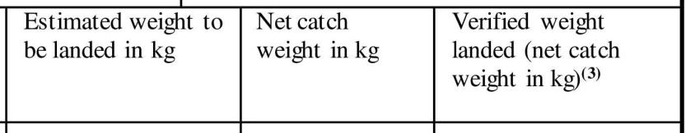

- Do exporters need to provide new information about the catch area? If yes, what specific new information is required?
Yes, more information about the catch area will be required for each species caught by each fishing vessel within the referred catch dates, such as:
-FAO area(s); and
-Exclusive Economic Zone(s) and/or High Seas; and if applicable
-Relevant Regional Fisheries Management Convention Area(s).
This information is important for the identification of the applicable conservation and management measures which must be declared in the same catch certificate (box 4) and is part of the necessary information to confirm the legality of the fishing activities.
Multiple catch areas must be indicated for one vessel if a fishing trip took place in several areas. But it is not necessary to include the FAO sub-areas and divisions.
- Do longitude and latitude (current system based on FAO Fishing Map) of the catch area need to be provided through CATCH following the amendments to the catch certificate?
No, providing the exact coordinates of the fishing area is not mandatory. However, more detailed information can always be provided through CATCH (by uploading supporting documents).
- Has IMO / UVI number become a mandatory field? What about vessels that do not have the IMO or a UVI number? Can the RFMO- or the flag State-issued registration numbers be used to fulfill this requirement?
The IMO number must be provided if such number is mandatory for the vessel under the International Convention for the Safety of Life at Sea (SOLAS), or a regional fisheries management organization (RFMO), or national legislation; and in any other case where the IMO number has been assigned to the vessel.
If the vessel concerned has been assigned a UVI (unique vessel identifier) e.g. under a RFMO, such number must be provided.
If neither of the previous two applies, the flag State national registration number suffices.
- Is the landing authorisation in box 7 of the catch certificate only required where transhipment has taken place, or is transhipment and landing treated as two separate scenarios for the purpose of this section?
These are two separate scenarios. Landings must be included when they take place in another third country than the flag State, whereas a transhipment within a port area must be included in all cases, i.e. regardless of whether it takes place in a port area of the flag State or in a port area of another third country.

- Has the use of processing statement (Annex IV) changed and from when?
- Yes, the amendment to the IUU Regulation introduces an important change concerning the use of the processing statement (Annex IV) that applies as of 10 January 2026. See also Q49.What are the changes to the processing statement (Annex IV) template?
The amended template of the processing statement laid down in Annex IV includes the obligation to apply a unique number, that must be provided by the authorities endorsing the statement.
- When is a processing statement (Annex IV) needed?

Processing operations requiring a processing statement (Annex IV) include cutting, filleting, canning, smoking, salting, cooking, pickling, drying or preparing fish for market in any other manner. Fishery products subject only to freezing and/or packing do not require a processing statement (Annex IV).
- Is a processing statement (Annex IV) needed for processing operations authorised by the flag States on board of its catching vessels?
No. For more information on the use of processing statements, see Q49.
- What will be the requirements to import into the EU fishery products, which transited, were stored and/or split into different consignments in a non-EU country other than the flag State or the processing State, and which have not undergone any operations other than unloading, reloading or any operation designed to preserve them in good and genuine condition?
In these cases, the fishery products will have to be accompanied by a catch certificate, a processing statement (Annex IV) if relevant, and documented evidence that fishery products did not undergo operations other than unloading, reloading or any operation designed to preserve them in good and genuine condition, and that they remained under the surveillance of the competent authorities in that non-EU country. Such evidence must be provided as follows:
- if the consignment is not split in that non-EU country, a single transport document issued to cover the passage through that non-EU country from the territory of the flag State or the State in which processing takes place, is required;
- if the consignment is split in different sub-consignments in that non-EU country, a non-manipulation document validated by the competent authorities of that country is required for each sub-consignment.
A template for the non-manipulation document has been established through the Commission Delegated Regulation (EU) 2025/453 of 18 December 2024, published on 6 March 2025[7]. The use of this document is mandatory as of 10 January 2026.
Note that the non-manipulation document can also be used in cases when the consignment is not split, instead of the single transport document.
61.a When is a non-manipulation document required?
Where applicable (see Q61), the non-manipulation document is mandatory only for the last segment of the product’s journey to the EU. This means that a non-manipulation document must be either issued by every non-EU country of transit after export from the flag State to the EU (if there were no processing operations in these countries of transit), or by every non-EU country of transit after export from the last processing State to the EU.
To note that non-EU countries can provide such document for other parts of the journey (i.e. for segments before export to the EU), on a voluntary basis.
In CATCH, the non-manipulation document is available in the exporter workflow; therefore, EU operators can submit, and EU Member States’ competent authorities can sign this document in CATCH.
61.b. Which authorities should sign the non-manipulation document?
The IUU Regulation does not specify which authorities should sign this document; therefore, the countries of transit determine which authorities are responsible for signing the declaration provided in box 8 of the non-manipulation document.
61.d Can a bill of lading be used as a single transport document? The single transport document referred to in Article 14 paragraph 1(b)(i) of the IUU Regulation must certify that the fishery products did not undergo operations other than unloading, reloading or any operation designed to preserve them in good and genuine condition, and remained under the surveillance of the competent authorities in that third country. The bill of lading does not include a confirmation that the fishery products remained under the surveillance of the competent authorities and therefore does not meet the requirements laid down in this paragraph.
There is no binding template for the single transport document; it can be a document simply stating that the products indeed did not undergo operations other than unloading, reloading or any operation designed to preserve them in good and genuine condition, and remained under the surveillance of the competent authorities in that third country. However, this document must be issued by a competent authority of the relevant country.
To note, the non-manipulation document can be used also in cases when the consignment is not split, instead of the single transport document.
- I am a non-EU country processor. How to fill the weight boxes of the processing statement (Annex IV) based on the related catch certificate?
The weight information in the catch certificate is available in the box “Net catch weight in kg” or “Verified weight landed (net catch weight in kg)”.
Box 3 catch certificate
Net catch weight in kg | Verified weight landed (net catch weight in kg) (3)

The box “total landed weight (kg)” in the processing statement should indicate the quantity that appears in box 3 of the corresponding catch certificate, even if not all the fish referred to in box 3 has been used in the processing country.
Note that in cases of processing of fishery products on board of factory vessels after transhipment from a donor vessel(s), the box of the processing statement “total landed weight (kg)” should be read as “total weight received from transhipment (kg)”.
Processing Statement
Catch certificate number | Vessel name(s) and flag(s) | Validation date(s) | Catch description | Total landed weight (kg) | Catch processed (kg) | Processed fishery product (kg)

The box “Catch processed (kg)” in the processing statement should indicate the weight of the fish that has been processed (total or partial amount of the weight declared in the column “Total landed weight (kg)”).
Catch certificate number | Vessel name(s) and flag(s) | Validation date(s) | Catch description | Total landed weight (kg) | Catch processed (kg) | Processed fishery product (kg)

The “Processed fishery product (kg)” in the processing statement should indicate the weight of the fish contained in the final product (not considering other ingredients such as oil, brine, salt, or vegetables).
Catch certificate number | Vessel name(s) and flag(s) | Validation date(s) | Catch description | Total landed weight (kg) | Catch processed (kg) | Processed fishery product (kg)

The net weight of the final product to be exported (i.e. including other ingredients such as oil, brine, salt, or vegetables) is not mandatory in the processing statement (Annex IV).
In addition, to note that, in CATCH, it is possible to select different product codes for the same species, if the same species undergoes different processing operations.
- How to use processing statements (Annex IV) in case the catches certified by one or more catch certificates are subject to more than one processing operation in one or more non-EU countries? How to link a processing statement to a subsequent processing statement in these cases?
In the case of fishery products subject to several processing operations in the same establishment, only one processing statement is required for the final product.In the case of fishery products subject to more than one processing operation in the same country but in different processing plants or in a different country, a processing statement (Annex IV) is required for each processing operation.
The processing statement endorsed for the subsequent processing operation should make reference to the preceding processing statement, indicating - in an additional box - its document number and the quantity of product from the preceding processing statement (i.e. the quantity declared in the box “processed fishery product (kg)” in that previous processing statement).
A template including such an additional box is provided below and in Annex I (“Processing statement subsequent to processing statement(s)”) and can be used on a voluntary basis.
The operator(s) concerned may submit, on a voluntary basis, additional details on transport from the point of processing to the subsequent point of processing. Such traceability information will facilitate possible verification of the identity of the final products exported to the EU (see also Q74).
The use of this additional box for subsequent processing statements as well as additional information on transport between two points of processing is also possible in CATCH, both for EU importers, in case they receive paper-based documents, and in cases operators and authorities in non-EU countries decide to use CATCH directly for the creation and endorsement of the required documents under the EU catch certification scheme.
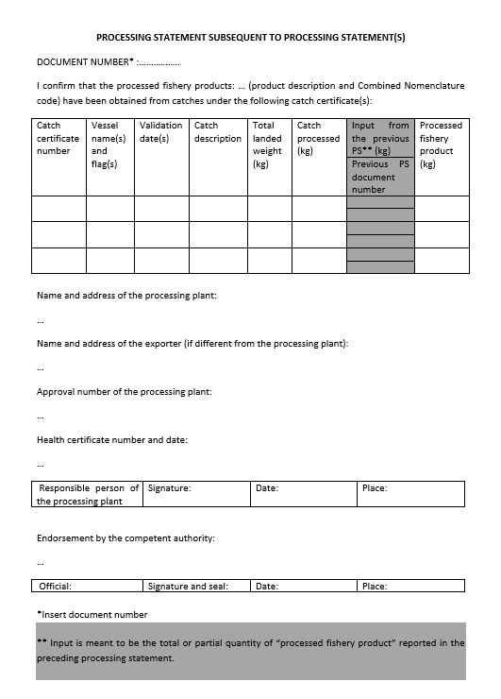

- Can simplified catch certificates be linked to a processing statement (Annex IV) in CATCH?
Yes, CATCH allows to select simplified catch certificates when creating and endorsing a processing statement (Annex IV).
- Fishery products from an operator in a non-EU country using CATCH directly to create and validate the catch certificates are sent to a processing operator in another non-EU country which is not using CATCH. The products, after processing, are exported to the EU. In this case, the authorities responsible for the endorsement of the processing statement receive the catch certificate that has been created and validated in CATCH as a PDF document electronically signed by the flag State. How is it possible for the competent authorities of the country, where processing takes place, to verify the validity of this catch certificate?
If the authorities of the country where the processing operation takes place do not use CATCH, they do not have access to the system to check the validity of the catch certificate. However, the authorities can scan the QR code on the catch certificate which allows them to check its validity.
In case of doubt, the authority of the processing country can in any case verify the content of the catch certificate directly with the flag State in question.
It is however highly recommended to continue the paperless flow (using CATCH) also in the processing country.
- Fishery products from an operator in a non-EU country whose authorities continue validating the catch certificates on paper are sent to another non-EU country for processing, and this country uses CATCH. The products, after processing, are exported to the EU. In this case, can the authorities endorse the processing statement in CATCH after receiving paper catch certificates?
No, in cases where the catch certificates continue to be validated on paper, all the subsequent steps in the documentary flow need to be paper based, including subsequent endorsement of processing statements.
66.a In CATCH, is there a limitation on the number of vessels to be included in the catch certificate and in the processing statement (Annex IV)?
There is no limitation on the number of vessels to be entered into the catch certificate in CATCH, nor into the processing statement (Annex IV). See also Q37.a on automatic transfer of data, including on vessels, from a catch certificate to a processing statement in CATCH.

EU IMPORTER DECLARATION AND TRANSITIONAL PROVISIONS
- When the use of CATCH becomes mandatory for EU importers, for some time they will continue receiving catch certificates and related documents which were validated days, weeks or even months before, i.e. using the templates that were in force before 10 January 2026. How can importers use CATCH if they receive these documents (using the templates applicable before 10 January 2026)?
- The documents validated, endorsed, signed or declared before the obligation to use the new template will continue to be accepted, but their submission by the EU importer to the authorities in the Member States must be done through CATCH. Therefore, until 10 January 2028, CATCH will offer the possibility to introduce information from the original templates (i.e. the ones applicable before 10 January 2026). Is it possible to have both simplified catch certificates and normal catch certificates accompanying one consignment? If yes, is it possible to submit an importer declaration in CATCH linked to both simplified catch certificates and normal catch certificates?
Yes, a consignment can be accompanied by both simplified catch certificates and normal catch certificates, and it is possible that the same importer declaration is linked to simplified and normal catch certificates.
- Is the importer declaration for simplified catch certificates the same as the one for the normal catch certificates after 10 January 2026? Is the importer declaration for catch certificates created before and after 10 January 2026 the same?
From 10 January 2026, all importer declarations must be created and submitted in CATCH in accordance with the amended box 11 (Annex II).
This will apply for all consignments regardless of whether they are accompanied by simplified catch certificates or normal catch certificates and regardless of whether they were validated before or after 10 January 2026. This importer declaration is part of CATCH, and this system is obligatory to use for the submission of all importer declarations as of 10 January 2026.
- Is it possible, after 10 January 2026, to create in CATCH a processing statement linked to an old (validated before 10 January 2026) catch certificate and a new (validated after 10 January 2026) catch certificate?
Yes, it will be possible to link old catch certificates and new catch certificates to the same processing statements (Annex IV) until 10 January 2028. After that, old catch certificates will no longer be accepted in CATCH.
- Article 16(1) states that “the catch certificate together with all the relevant accompanying documents shall be submitted at least three working days before the estimated time of arrival at the place of entry into the territory of the Union”. Is the derogation granted by Article 8 and Annex VI of Regulation (EC) No. 1010/2009 still applying to the submission of the documents in CATCH?
- Yes, the provisions set out in Article 8 and Annex VI to Regulation (EC) No. 1010/2009 have not been modified by the Commission Implementing Regulation 2025/1522, therefore this derogation continues to apply for the submission of the documents in CATCH. Which weights must be provided in the EU importer declaration (box 11) in CATCH after 10 January 2026?
As of 10 January 2026, the importer has to select in CATCH the corresponding catch certificate or processing statement (Annex IV) and launch the importer declaration. Then the importer has to select the products by EU CN code.
For each of the EU CN codes selected the importer must fill the box “Net fishery product weight in kg” (i.e. the weight of the fish contained in the product not considering other ingredients such as oil, brine, salt, or vegetables etc.).
Box 11
Product description | CN code | Net weight in kg | Net fishery product weight in kg

The importer is also requested to provide the “net weight in kg” of the product intended to be imported (i.e. including other ingredients such as preservation materials, brine, salt etc.).
This weight should correspond to the net weight of the product declared to customs. It is not always the weight found in the catch certificate or processing statement.
Box 11
Product description | CN code | Net weight in kg | Net fishery product weight in kg

- How to fill the “Net fishery product weight in kg” of the EU importer declaration (box 11) in CATCH after 10 January 2026?
The importer has to select in CATCH the corresponding catch certificate or processing statement (Annex IV) and launch the importer declaration. Then the products have to be selected by EU CN code.
Box 11 “Net fishery product weight in kg”
For each of the EU CN codes selected, the importer has to fill the box “Net fishery product weight in kg” (i.e. the weight of the fish contained in the product not considering other ingredients such as oil, brine, salt, or vegetables etc.).
Box 11
Product description | CN code | Net weight in kg | Net fishery product weight in kg

Relevant information on such weight is available in the received documents accompanying the consignment (catch certificates, processing statements (Annex IV) and, in case of consignments split when in transit through a non-EU country different from the flag State or processing State, non-manipulation document).
- Consignments accompanied only by a catch certificate
If the consignment is accompanied only by a catch certificate, the relevant information to fill the box “Net fishery product weight in kg” (box 11) is the weight indicated in the catch certificate in the box “Net catch weight in kg” or “Verified weight landed (net catch weight in kg)”.
Box 3 catch certificate
Net catch weight in kg | Verified weight landed (net catch weight in kg) (3)

In case only part of the weight of the fish covered by the catch certificate is declared for importation, that partial weight should be provided in the importer declaration in the box “net fishery product weight in kg”.

- Consignments accompanied by a catch certificate and a processing statement (Annex IV)
If the consignment is accompanied by a catch certificate and a processing statement (Annex IV), the relevant information to fill the box “Net fishery product weight in kg” (box 11) is the weight indicated in the box “Processed fishery product (kg)” of the processing statement which provides the weight of the fish contained in the product (not considering other ingredients such as oil, brine, salt, or vegetables).
Processing statement
Catch certificate number | Vessel name(s) and flag(s) | Validation date(s) | Catch description | Total landed weight (kg) | Catch processed (kg) | Processed fishery product (kg)

If only part of the weight of the fishery product referred to in the processing statement is declared for importation, that partial weight should be provided in the importer declaration in the box “net fishery product weight in kg”.
- Consignments accompanied by a catch certificate, with or without a processing statement, and a non-manipulation document
If the consignment is accompanied by a catch certificate, with or without a processing statement, and a non-manipulation document, the relevant information to fill the box “Net fishery product weight in kg” (box 11) is the net fishery product weight indicated in the non-manipulation document.
If only part of the weight of the fishery product referred to in the non-manipulation document is declared for importation, that partial weight should be provided in the importer declaration in the box “net fishery product weight in kg”.
- Is it the responsibility of the EU importer to complete transport details in the appendix to the catch certificate, or will the exporter be required to complete this?
The exporter has to complete the details of the first transport from the point of export in the appendix to the catch certificate. If any information on transport is missing (for subsequent transport journeys outside the control/knowledge of the exporter), the importer can be requested to provide it. The importer, in any case must provide in box 11 (importer declaration), the means of transport upon arrival of the consignment.

In CATCH, the importer is able to provide additional information on transport details, if needed. . In the importer declaration, subsequent means of transports (after the point of export) can be included on a voluntary basis, if this information is available to the importer. This will allow a complete view of the journey of the fishery products and ensure better traceability.

74.a. What if the information on the transport details is not available to the exporter at the time of submitting catch certificate to the flag State authority for validation, and this information is provided later to the exporter?
In CATCH, in case information on the means of transport are not yet available, the exporter can still submit the catch certificate to its competent authorities without having filled in the tab on transport details. After validation of the catch certificate by the competent authorities, the exporter can fill in the said tab when transport details are known. However, the catch certificate cannot be sent to the next operator without the transport details tab filled in.

(NEW SECTIONS)

CHANGES TO THE SIMPLIFIED CATCH CERTIFICATE INTRODUCED BY THE AMENDMENT OF THE IMPLEMENTING REGULATION (EC) 1010/2009

- What changes have been introduced through the amended Implementing Regulation in relation to the use of the simplified catch certificate?
Article 6 of the Implementing Regulation 1010/2009, laying down the criteria for the use of the simplified catch certificate, has been amended. These amendments will apply as of 10 January 2027. According to the new provisions, the simplified catch certificate only applies to catches made by third country fishing vessels:

- with an overall length of less than 12 metres without towed gear; or
- with an overall length of less than 8 metres with towed gear.

- Has the content of the simplified catch certificate been modified and when will these changes start to apply?
The template of the simplified catch certificate has been revised (see Annex II to the amended Implementing Regulation). This template has been adapted in view of the use of CATCH and of the modification introduced in the template of the normal catch certificate in the amended IUU Regulation.

The changes are:
- Contact details of the validating authority: only the telephone number and the email address are requested.
- List of vessels: the name of the vessel, the national registration number, the quantity, and the catch date are requested for each vessel. (Box 3)
- Contact details of the exporter: only the address and/or telephone number is requested. (Box 4)
- Transport details appendix has been modified in accordance with the changes made in the normal catch certificate. (Box 10)
- The importer declaration has been modified in accordance with the changes made in the normal catch certificate. (Box 11)

Note that the list of vessels (box 3) can remain an annex to the simplified catch certificate (in case the documents continue to be submitted in paper-version). However, all the fields indicated in box 3, i.e. the name of the vessel, the national registration number, the quantity, and the catch date, are mandatory information. As regards the catch date, it can be the landing date of the fishery products.

- I am representing a non-EU country competent authority, and I am in charge of the validation of EU simplified catch certificates (flag State authority notified in accordance with Article 20(1) of the EU IUU Regulation). What will be the impact of the amended Implementing Regulation on my authority and is there anything I should do?
The amendments to the Implementing Regulation have been notified by the European Commission, on behalf of the EU, to the World Trade Organisation on 13 November 2025.
In addition, the European Commission has contacted all non-EU countries (flag States) who submitted notifications in accordance with Article 20(1) of the EU IUU Regulation and provided them with information regarding the changes introduced by this amendment to the Implementing Regulation.
As indicated in Q75, the criteria for the use of the simplified catch certificate have been modified, taking into account only the length of the vessel, depending on the presence/absence of towed gear. Therefore, certain vessels in non-EU countries may not be subject to the use of the simplified catch certificate anymore.

In addition, as indicated in Q76, some modifications have been introduced as regards the information that must be provided in the simplified catch certificate.

- When do these changes start applying?
In accordance with Article 2 of the amended Implementing Regulation, Article 6 on the use of simplified catch certificate and Annex II (its template) will be applicable as of 10 January 2027.

To note that until 10 January 2028, the importer may use the original template of the simplified catch certificate for certificates validated before 10 January 2027 (see Q79 to 81 for further information on the transitional periods).

TRANSITIONAL PERIOD/USE OF THE EU TEMPLATES

- Until when can non-EU countries use the original templates of the normal catch certificate, of the processing statement (Annex IV) and of the simplified catch certificate?
As of 10 January 2026, it is introduced:
- a revised template for the normal catch certificate;
- a revised template for the processing statement (Annex IV).
From 10 January 2026 until 10 January 2028, a transitional period applies for normal catch certificates validated and/or processing statements (Annex IV) endorsed before 10 January 2026 and presented for importation before 10 January 2028.
If normal catch certificates have been validated and/or processing statements (Annex IV) have been endorsed after 10 January 2026, the revised templates must be used. In these cases, even if the catches were made prior to 10 January 2026, they must be validated through the revised templates, because the date of validation is the one determining the use of the templates.
As of 10 January 2027, a revised template for the simplified catch certificate is introduced (see Q76 and Q77). If the simplified catch certificate has been validated before 10 January 2027 and presented for importation to the EU before 10 January 2028, the original template of the simplified catch certificate can be used.
As of 10 January 2028, the revised normal catch certificate, the revised simplified catch certificate, and the revised processing statement (Annex IV) templates are mandatory for all countries, without exception.
For more information on the use of EU templates, see the infographics added in Annex II to this FAQs document.
- From when is the use of the template of the non-manipulation document mandatory? Is there also a transitional period for this document?
The use of the non-manipulation document template is mandatory as of 10 January 2026 for the documents declared/signed after that date.

There is no transitional period for this.

- Do the administrative arrangements (also called “agreed records”) established with seven non-EU countries continue to apply after 10 January 2026? Can these seven countries continue using their specific catch certificate templates based on administrative arrangements?
As of 10 January 2026, the administrative arrangements established between the European Commission and seven non-EU countries are terminated. These countries can no longer use the templates set out in the administrative arrangements and must use the templates as laid down in the IUU Regulation and the Implementing Regulation.
As with the original templates for normal and simplified catch certificates and for the processing statement (Annex IV), a transitional period is also foreseen for the use of catch certificate templates of these seven countries.
For catch certificates validated before 10 January 2026 and presented for importation to the EU before 10 January 2028, the template of the administrative arrangements remains applicable. In CATCH, the original template of the catch certificate has to be selected and, depending on the flag State that validated the catch certificate, certain validation (exemption) rules will apply, i.e. some data will not be required for these seven non-EU countries (in accordance with their specific templates).
For catch certificates validated and/or processing statements (Annex IV) endorsed after 10 January 2026:
- If the catch certificates have been validated and/or processing statement (Annex IV) endorsed between 10/01/2026 and 10/01/2027: these seven non-EU countries must use the revised catch certificate and the revised processing statement (Annex IV) templates but can use the original simplified catch certificate template (as laid down in Implementing Regulation 1010/2009).
- If the catch certificates have been validated and/or processing statement (Annex IV) endorsed after 10 January 2027, the revised normal catch certificate, the revised simplified catch certificate and the revised processing statement (Annex IV) templates must be used.
This transitional period will end on 10 January 2028. As from that date, the seven non-EU countries must use, as all other non-EU countries, the revised template of the normal catch certificate, of the processing statement (Annex IV) and of the simplified catch certificate in all cases.
For further information on the transitional periods, see Annex II to this FAQs document (particularly the infographic ‘non-EU countries with specific administrative arrangements’).

ANNEX I
PROCESSING STATEMENT SUBSEQUENT TO PROCESSING STATEMENT(S)

DOCUMENT NUMBER* :…………….
I confirm that the processed fishery products: … (product description and Combined Nomenclature code) have been obtained from catches under the following catch certificate(s):
Catch certificate number | Vessel name(s) and flag(s) | Validation date(s) | Catch description | Total landed weight (kg) | Catch processed (kg) | Input from the previous PS** (kg) | Processed fishery product (kg)
 |  |  |  |  |  | Previous PS document number | Processed fishery product (kg)
Name and address of the processing plant:
…
Name and address of the exporter (if different from the processing plant):
…
Approval number of the processing plant:
…
Health certificate number and date:
…
Responsible person of the processing plant | Signature: | Date: | Place:

Endorsement by the competent authority:
…
Official: | Signature and seal: | Date: | Place:

*Insert document number.

** Input is meant to be the total or partial quantity of “processed fishery product” reported in the preceding processing statement.

ANNEX II

TRANSITIONAL PERIOD/ USE OF THE EU TEMPLATES

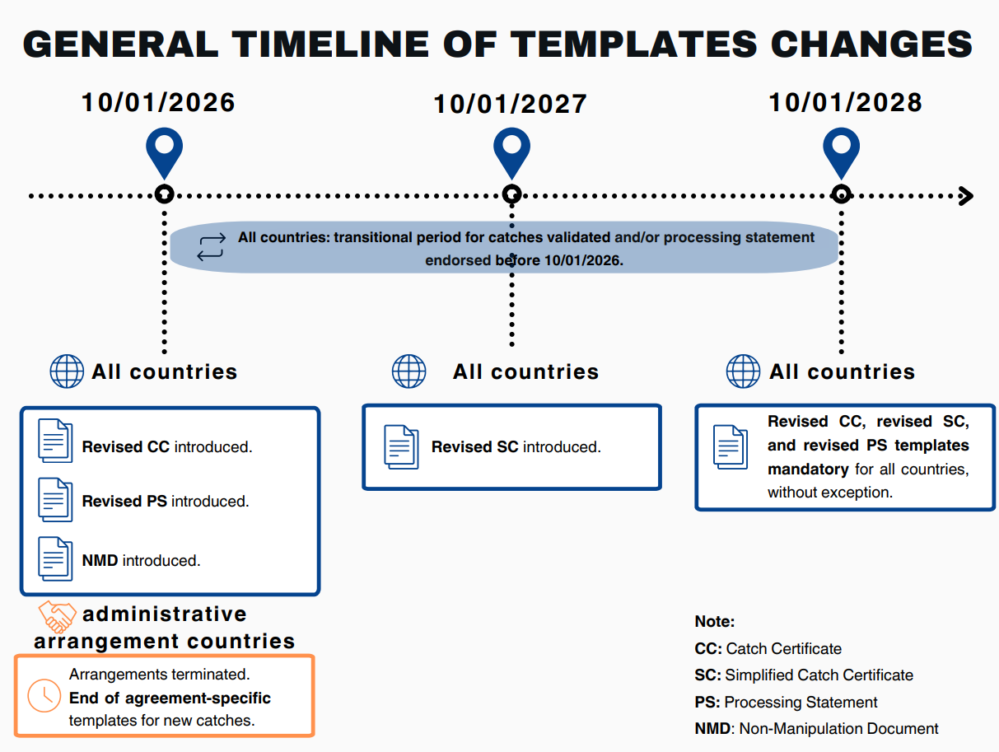

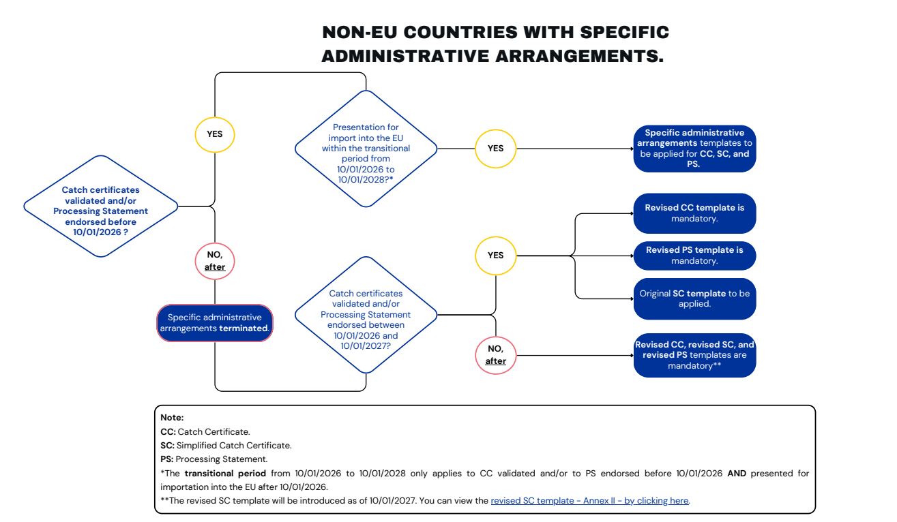
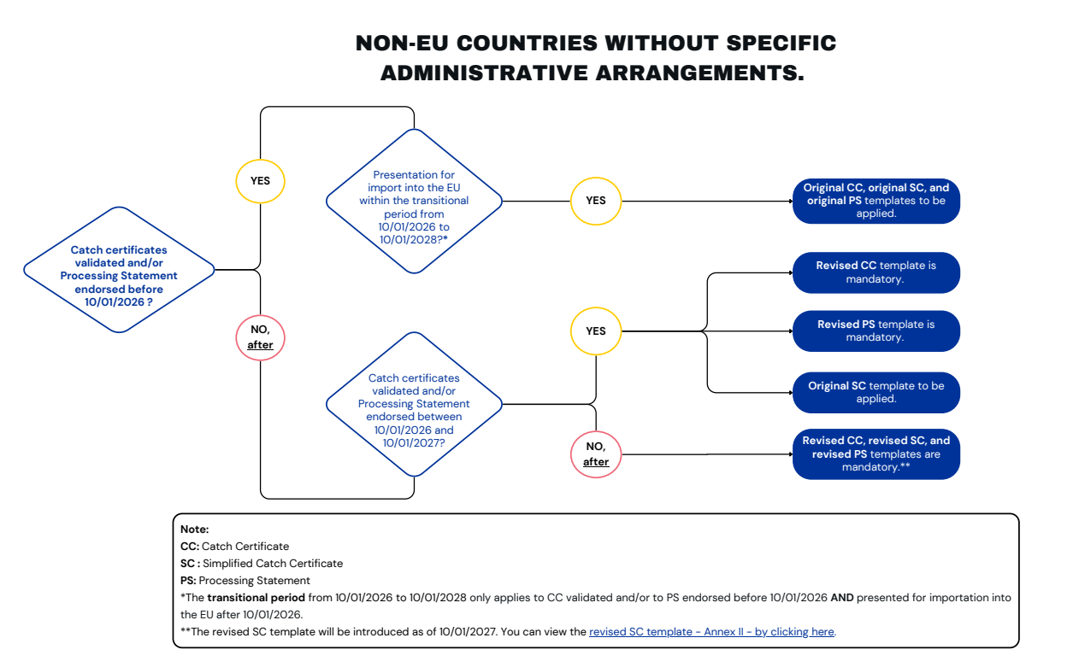

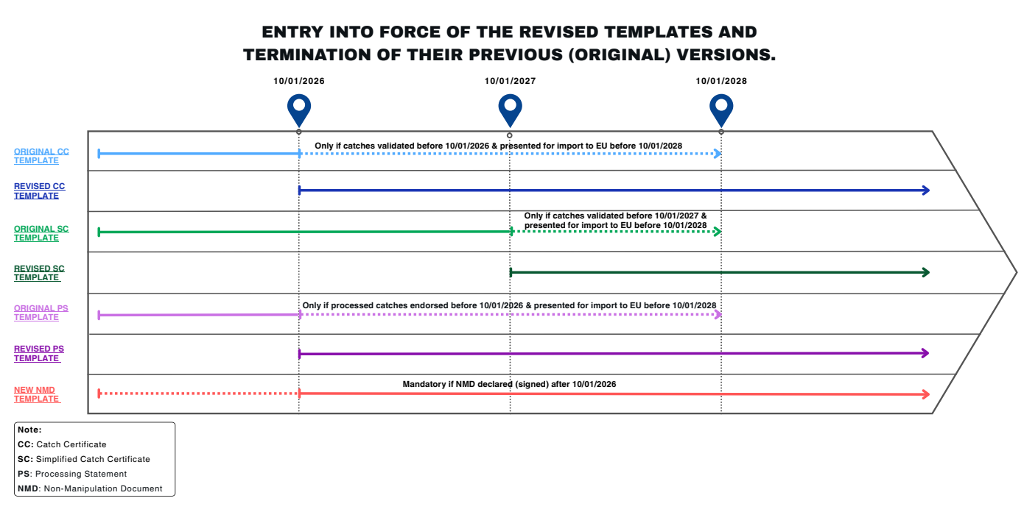

Two years after the entry into force of Regulation (EU) 2023/2842 of the European Parliament and of the Council of 22 November 2023.
As amended by Commission Implementing Regulation (EU) 2025/1522 of 28 July 2025 amending Regulation (EC) No 1010/2009 laying down rules for the implementation of Council Regulation (EC) No 1005/2008 establishing a Community system to prevent, deter and eliminate illegal, unreported and unregulated fishing, http://data.europa.eu/eli/reg_impl/2025/1522/oj.
See Article 6a(9) of Regulation (EC) No 1010/2009, as amended by Commission Implementing Regulation (EU) 2025/1522 of 28 July 2025, http://data.europa.eu/eli/reg_impl/2025/1522/oj.
See also Article 6a, point 11 and Article 36 of the Commission Implementing Regulation (EC) No 1010/2009, as amended by Commission Implementing Regulation (EU) 2025/1522 of 28 July 2025, http://data.europa.eu/eli/reg_impl/2025/1522/oj.
The list of the countries can be found here.
This also concerns Overseas Countries and Territories (OCTs).
See Q79 to Q81 for further information on transitional period and the use of templates.
See Annex IX of the Implementing Regulation No 1010/2009.
These infographics can also be found here.

