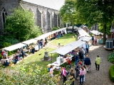
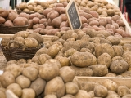

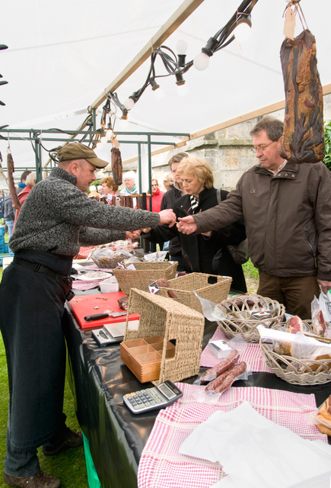

International market for regional products

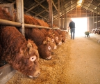



2
3
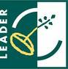 LEADER Zuid –Twente LEADER…… LEADER……

4
5

LEADER…… LEADER……



European Agricultural Fund for Rural Development:
Europe investing in rural areas

Date: 27 March 2010
Subject: Concept-project description for a transnational cooperation project
Contact person: Antje Grolleman
LAG Zuid –Twente, The Netherlands
www.leaderzuidtwente.nl (per 20 April 2010)

Table of content

Chapter 1: Introduction

Chapter 2: Present situation

Chapter 3: Implementation and expected results

Chapter 4: Planning

Chapter 5: Costs

Chapter 1: Introduction

Transnational cooperation got high priority in the LEADER program when it was approved for the period 2007-2013. It even became one of the most salient features of the program during this period. Prior to 2007, international collaboration was important too, but the European Commission has improved facilities by adjusting the approach and budgets to the new priorities for the present phase. These priorities refer to the core objectives of RDP-2: improving competitiveness, improving the environment and improving quality of life in rural areas. Cooperation is considered one of the most powerful means to achieving these objectives. The Dutch Rural Network puts it this way: collaboration between different areas, countries and action groups is inspiring, leads to refreshing views, creativity and generates new momentum. The LEADER LAG (Local Action Group) Zuid-Twente is convinced that in particular this new momentum could result in a vital countryside in Europe.

In each LEADER region, funds have been allocated to set up collaboration at national as well as at international level. Various examples of successful cooperation can be found in the Netherlands. International collaboration is also a spearhead for the LAG LEADER Zuid-Twente since 2008. The main reason is that in EU funded programs, one could and also should look beyond boundaries. ‘The World stretches beyond Zuid-Twente’. This is expressed in the LEADER Zuid-Twente development strategy as: ’Focus on collaboration with projects outside the own region. The local concept of ‘noaberschap’ (neighbourhood solidarity) extends beyond the boundaries of the region!’ Partnerships are to be encouraged as collaboration improves knowledge and skills’!

The LAG is focussing on projects with added value for specific issues in the own region as well as in other areas. These issues to be addressed are:
- Strengthen ‘noaberschap’ (neighbourhood solidarity),
- Improve tourism by integrating nature, cultural heritage and agriculture,
- Improve rural - urban linkages,
- Increase transfer and exchange of information between knowledge centres and rural enterprises.

Various European regions do have characteristic agricultural products, which are also marketed in a region specific manner. The interest in regional products is sharply increasing in the Netherlands. Consequently, income from production and sale of regional produce is increasing in the Twente region as well. Based on this development, the LAG would like to inventory opportunities for collaboration, for marketing regional produce and to exchange experiences.

The LAG Twente has already gained considerable knowledge and experience regarding regional products. For example: producers have been assisted to form an association and to set up a sales outlet. The link www.streekmarkttwente.nl provides more information (in Dutch). The experience gained is a good starting point to study an international follow up to the market, and exchange and collaboration between entrepreneurs. The LAG would like to build on this experience with international partners.

Chapter 2: Present situation

Regional products (local food) have been heavily promoted in The Netherlands in recent years. Also farmers try to generate (part of their) income by selling regional produce. Initially, selling regional products was mainly to support tourism, but now it is increasingly turning into a business in itself. The Ministry of Agriculture even promotes regional products and market development through a special Task Force Multi-functional Agriculture. Also the LAG Zuid-Twente would like to contribute to this trend.
As mentioned earlier, regional products are sold by an increasing number of farms and it has become an important source of income in The Netherlands. The marketing of local grown or crafted products has improved tremendously. Networks that emphasize the importance of added value of regional products and its marketing have emerged.
Like Zuid-Twente, other LAGs and regions will also have specific products. The LAG is interested to find out more about regional products in other European regions, in particular regarding the following issues:
- How is the marketing of regional products organized in other European regions?
- How could marketing contribute to substantial farm income from regional products?
- What are typical regional products in other countries?
- Could Dutch regional products be sold in other countries and vice versa? What are the requirements?
- What are sustainable approaches to regional product development?
- Would it be possible to exchange and disseminate knowledge at international level?
In brief: what are the opportunities for a joint international approach and what are the constraints faced by other LAGs?

The LAG of LEADER region Zuid-Twente considers it an opportunity to realize an international market for regional produce through transnational collaboration. The initial (reconnaissance) stages of collaborative LEADER projects take a lot of time as described in the ‘Integrated Transnational Cooperation Guide’. Realizing the market also requires a lot of effort, knowledge, dedication and enthusiasm. Dissemination of information and interaction between farmers, the administration and rural organizations are important. LEADER Zuid-Twente aims at collaborating with about 5 other LEADER regions.

Chapter 3: Implementation and expected results

The LAG Zuid Twente would like to address two priorities. Firstly, the objective of this project is to organize one or more international markets for regional products. Exchange of knowledge and experience regarding regional products is the second spearhead.

The proposed activities and expected results are:
- Four opportunities for exchange between collaborating LAGs, producers and key actors in the regions involved
- Three international markets in different LEADER regions
- Identification of logistic arrangement that are required
- List of prospective participants (producers) per LEADER area
- List of products to be exchanged
- Develop methods to interactively exchange knowledge and experience between producers / LAG's
- Increase attention of international media for regional products
- An overview of various opportunities to exchange products between farmers
- Draw up a business plan for the organization of international markets for regional products
- Collect, process and disseminate information among farmers and organizations
- Evaluate all efforts
Target groups of the present project are:
- LEADER areas in Europe which are involved with regional products
- Producers of regional products in Twente and other LEADER areas
- Prospective buyers of regional products
- Tourists in the respective LEADER areas

Chapter 4: Planning

Assuming the cooperating LAGs to start project implementation in October 2010 and a project duration of 2 years, the desired planning of project activities is as follows:

October – December 2010
- Introductory meeting of collaborating LAGs and making an inventory of practices in the Netherlands
- Preparing the first international market of regional products

January - June 2011
- 1^{st.} international market of regional products in one of the participating LEADER regions
- A meeting to evaluate the 1^{st.} international market of regional products
- Prepare the 2^{nd.} international market

July – December 2011
- 2^{nd.} international market in one of the participating LEADER regions
- A meeting to exchange knowledge between producers of regional products
- Evaluating the 2^{nd.} international market
- Prepare 3^{rd.} international market for regional products

January – June 2012
- 3^{rd.} international market in one of the participating LEADER regions
- Evaluation of the 3^{rd.} market for regional products
- A meeting for involved LAGs to revise last years’ activities

July – October 2012
- Concluding meeting and closing of project
- Publishing joint results

Collaborating LAGs will keep in touch during the project period. Together they take care of achieving the results and the communication required. A plan of operations and the division of tasks will be elaborated in the preparation phase.

Chapter 5: Costs

The costs of the project are as follows:

Cost item | Amount (excluding VAT) | Amount (including VAT)
- Implementation | € 90.000,-- | € 107.100,--
- Project management | € 18.000,-- | € 21.420,--
- External advise | € 11.500,-- | € 13.685,--
- Promotion and publicity | € 31.000,-- | € 36.890,--
- Other | € 10.000,-- | € 11.900,--
Total | € 160.500,-- | € 190.995,--
NB: Travel expenditure to attend meetings is to be covered by the respective LAGs and is not included in project costs.

Chapter 6: Funding

The LAG Zuid Twente would like to invite five other regions to collaborate in this project. With six partners funding will be as follows:

Funding by source

Funding from | 50% from EU (LEADER) | 50% national co-financing | Total
- LEADER Zuid Twente | € 15.916,25 | € 15.916,25 | € 31.832,50
- LEADER……. | € 15.916,25 | € 15.916,25 | € 31.832,50
- LEADER…….. | € 15.916,25 | € 15.916,25 | € 31.832,50
- LEADER....... | € 15.916,25 | € 15.916,25 | € 31.832,50
- LEADER......... | € 15.916,25 | € 15.916,25 | € 31.832,50
- LEADER.......... | € 15.916,25 | € 15.916,25 | € 31.832,50

