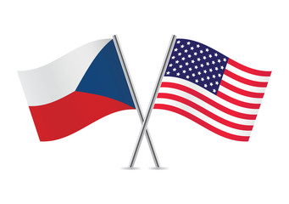

Czech-American

Wine & Liqueur Business Forum

Date: May 2, 2017
Venue: Ministry of Agriculture of the Czech Republic, Těšnov 65/17, Praha 1, Room. 101, Floor 1
12:30 PM | Registration of participants
1:00 PM - 1:10 PM | Welcome speech: Mr. Jiří Šír, Deputy Minister of Agriculture
1:10 PM – 1:15 PM | Welcome speech: Mr. Petr Ježek, Director, Trade and International relations Dept., Ministry of Agriculture of the Czech Republic
1:15 PM -1:35 PM | Mr. David Filip, Head of Unit for Wine, Ministry of Agriculture of the Czech Republic, „Wine and vine in the Czech Republic“
1:35 PM -1:50 PM | Mrs. Dagmar Fialová, Marketing Director of Sonberg Winery on behalf of Winemakers Association of the Czech Republic
1:50 PM -2:05 PM | Mr. Noah Ullman, Co-Owner of Czech Wine Imports, Inc., “Czech-American trade relations in wine industry, the "three tier" system of distribution in the US“,
2:05PM – 2:15 PM | Mr. Martin Déva, Rudolf Jelínek a.s., On exporting to the US
2:20 PM -3:00 PM | Refreshment and networking / tasting of selected wines
3:00 PM | End of the event
Presenter: Marino Radačič, Consulate General of the Czech Republic in Los Angeles
Working language: English
Register at: czechamericanwineliqueurforum@gmail.com

